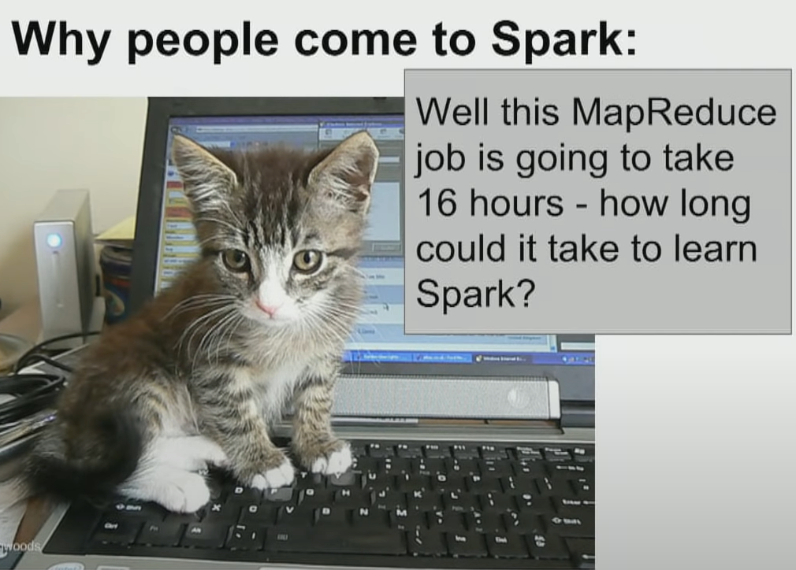

Datasources:

<https://dumps.wikimedia.org/other/pagecounts-raw/>

Classroom setup: %run "./Includes/Classroom-Setup"

Source for Wikipedia data: : 'wasbs://training@dbtrainwestus.blob.core.windows.net/'

path = source + "/wikipedia/pagecounts/staging\_parquet\_en\_only\_clean/"

https://www.youtube.com/watch?v=4xsBQYdHgn8

Databricks resources:

Localhost:4040

<https://databricks-prod-cloudfront.cloud.databricks.com/public/4027ec902e239c93eaaa8714f173bcfc/346304/2168141618055043/484361/latest.html>



DAG

<https://www.youtube.com/watch?v=LoFN_Q224fQ>

Splits operations on exchange

Spark is written in Scala that sits on top of Java (runs on JVM)

Spark since it is based on Java is strictly types (unlike Python)

Transformations are lazy and run only when an action is run. This allows Spark to optimize for performance (for example, run a filter prior to a join), instead of running commands serially. For a complete list of transformations and actions, refer to the Apache Spark Programming Guide: [Transformations](https://spark.apache.org/docs/latest/rdd-programming-guide.html#transformations) and [Actions](https://spark.apache.org/docs/latest/rdd-programming-guide.html#actions).

### transformations

Transformations are operations that will not be completed at the time you write and execute the code in a cell - they will only get executed once you have called a **action**. An example of a transformation might be to convert an integer into a float or to filter a set of values.

### Actions

Actions are commands that are computed by Spark right at the time of their execution. They consist of running all of the previous transformations in order to get back an actual result. An action is composed of one or more jobs which consists of tasks that will be executed by the workers in parallel where possible

Here are some simple examples of transformations and actions. Remember, these **are not all** the transformations and actions - this is just a short sample of them. We'll get to why Apache Spark is designed this way shortly!

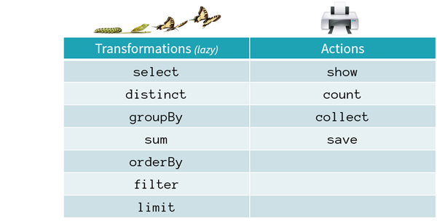

Spark can create databases from jSON where the columns can have a hierarchy. Seee hierarchy with printSchema

It supports both Pandas and SQL type manipulations

You can create user defined function and apply it on columns

To use the SQL queries, create a view

spark.sql.shuffle.partitions configures the number of partitions that are used when shuffling data for joins or aggregations.

spark.default.parallelism is the default number of partitions in RDDs returned by transformations like join, reduceByKey, and parallelize when not set explicitly by the user. Note that spark.default.parallelism seems to only be working for raw RDD and is ignored when working with dataframes.

If the task you are performing is not a join or aggregation and you are working with dataframes then setting these will not have any effect. You could, however, set the number of partitions yourself by calling df.repartition(numOfPartitions) (don't forget to assign it to a new val) in your code.

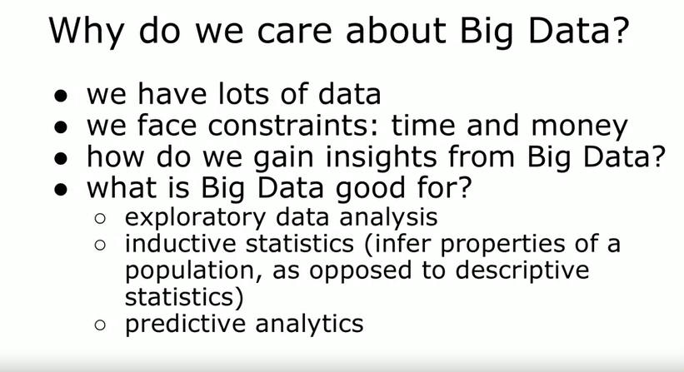

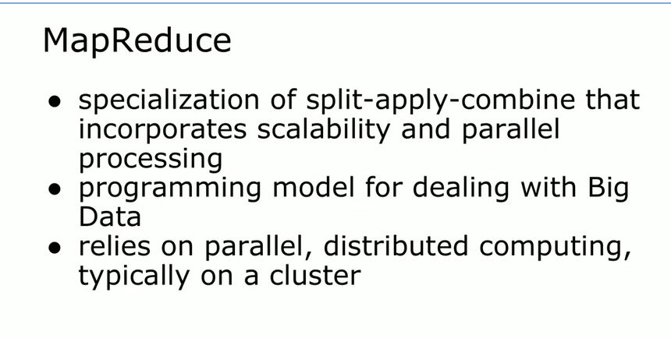

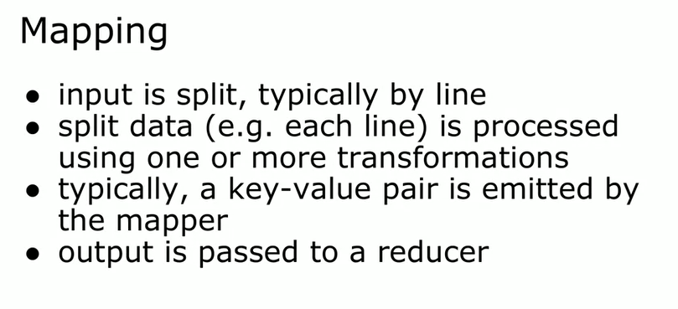

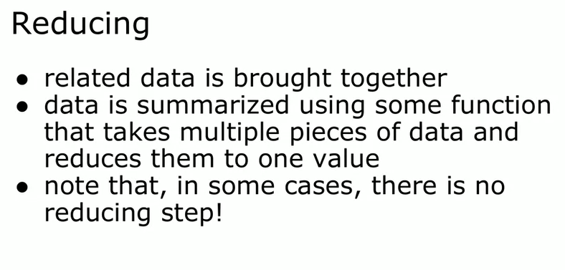

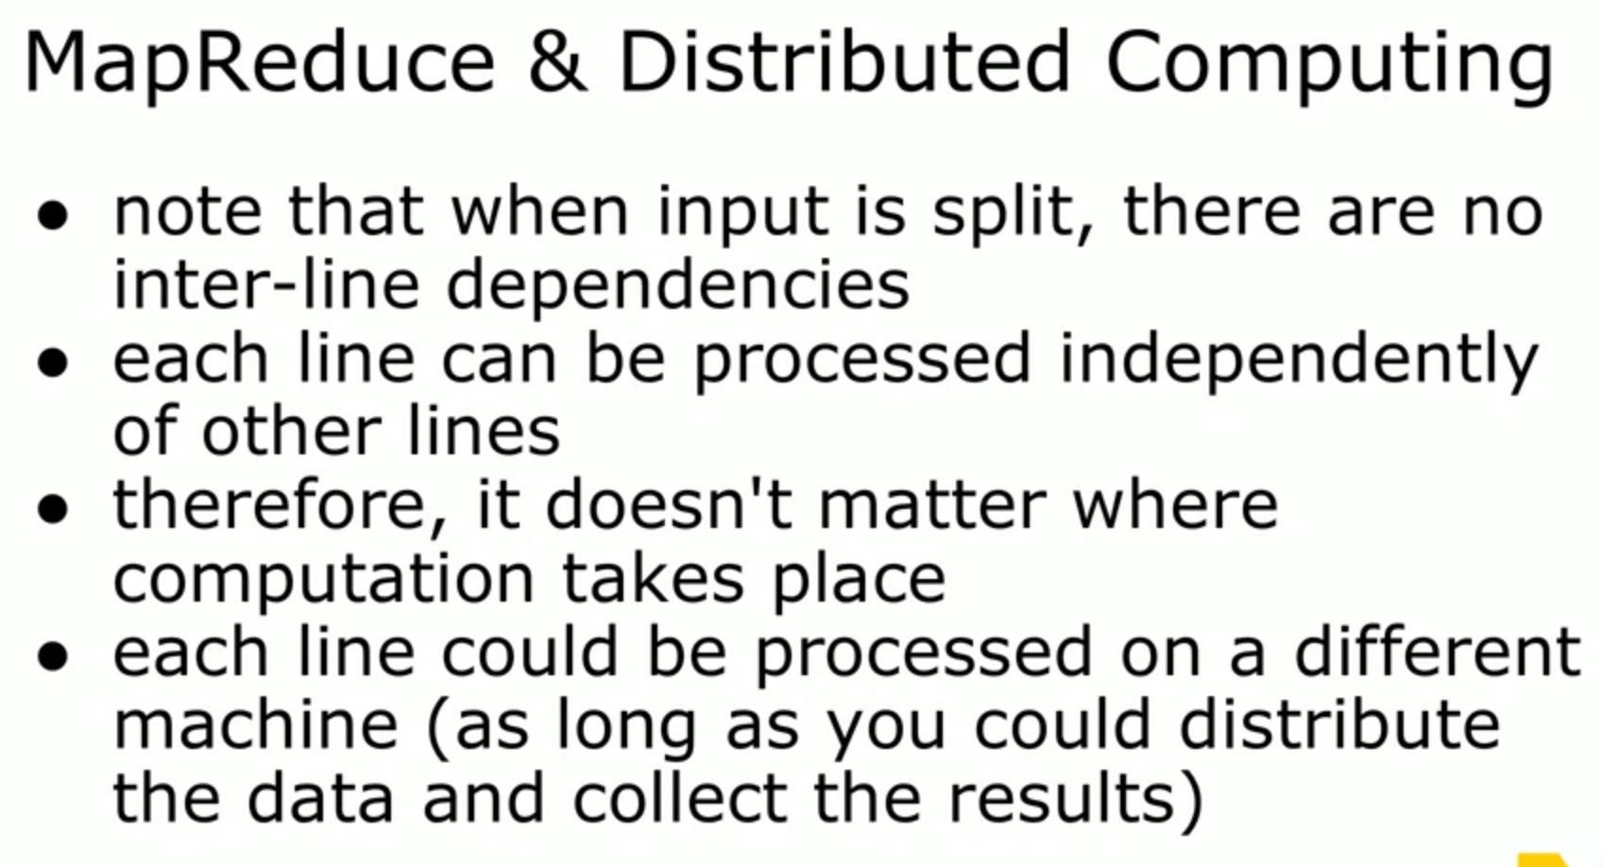

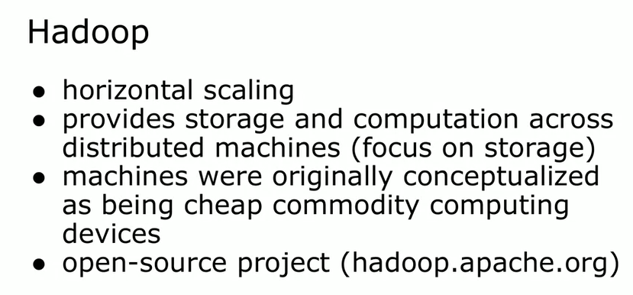

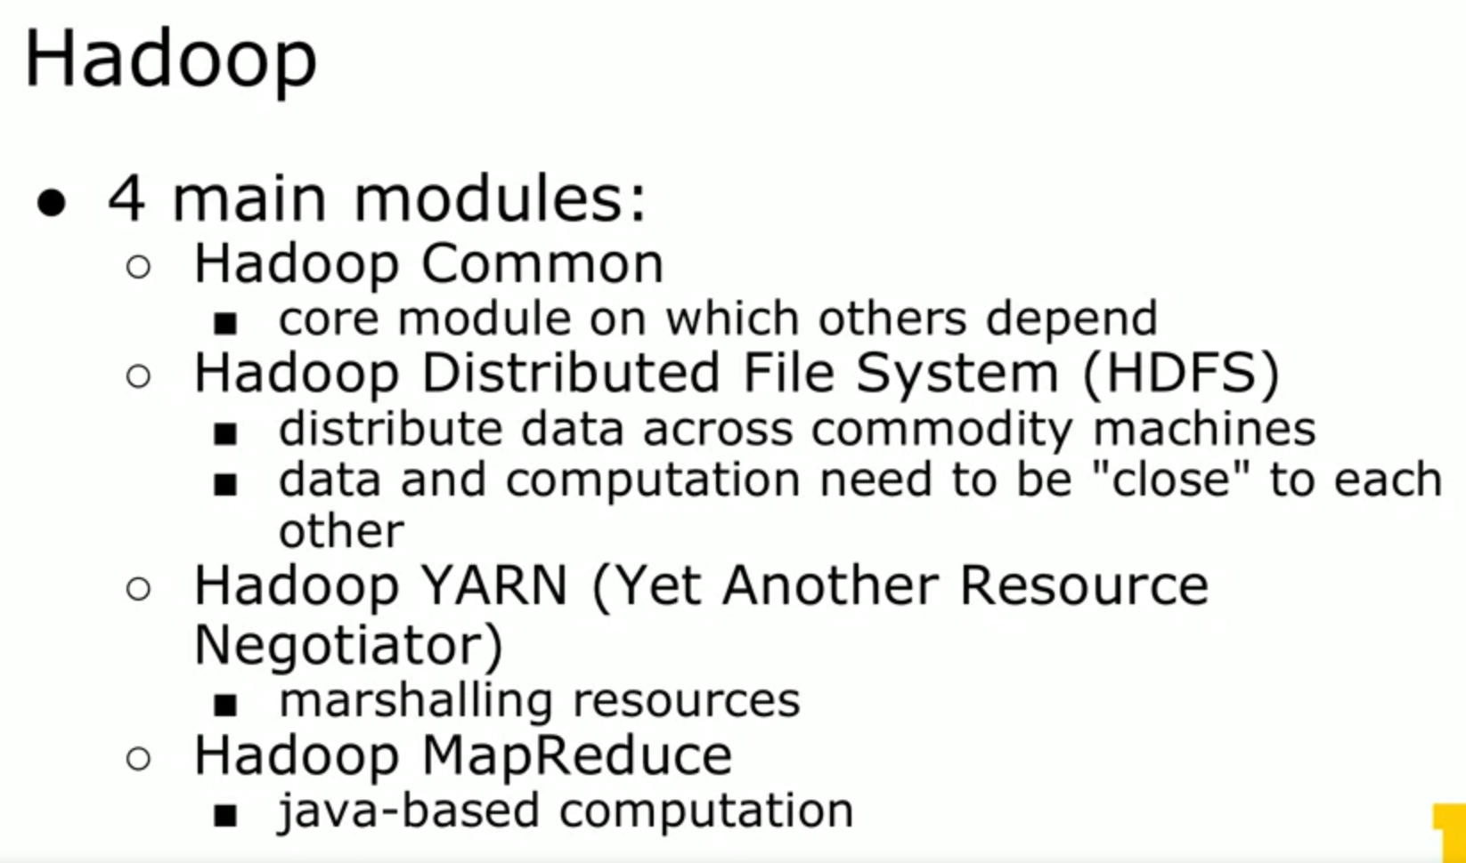

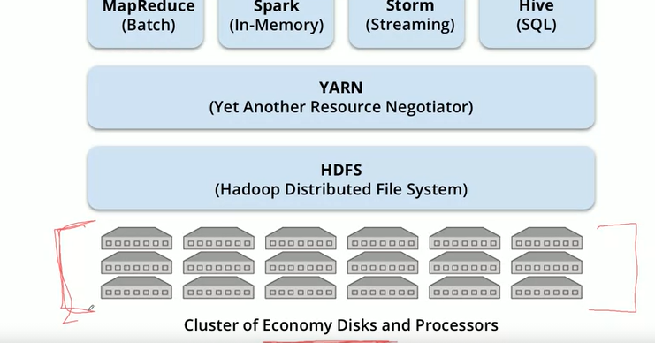

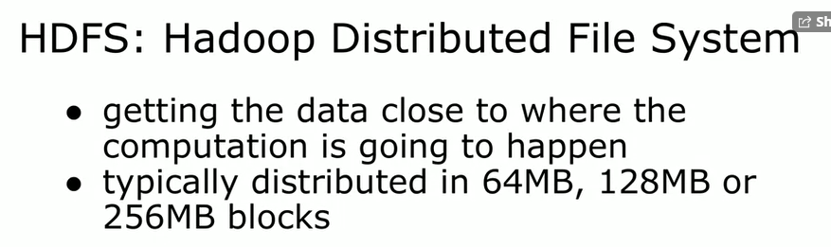

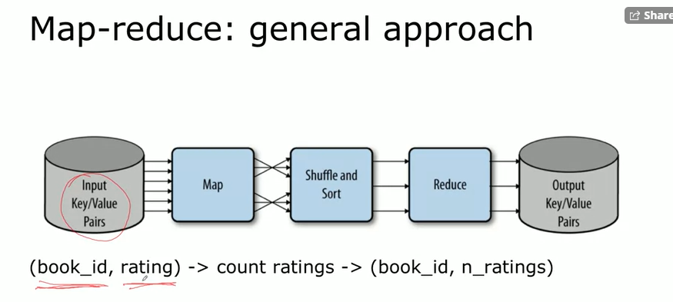

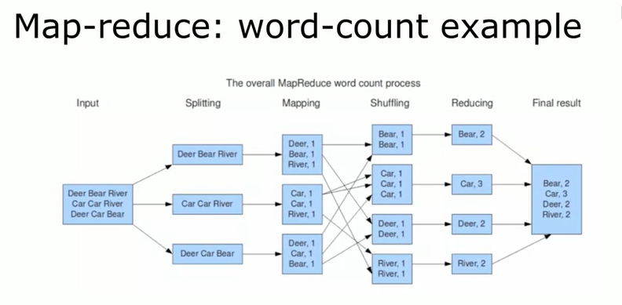

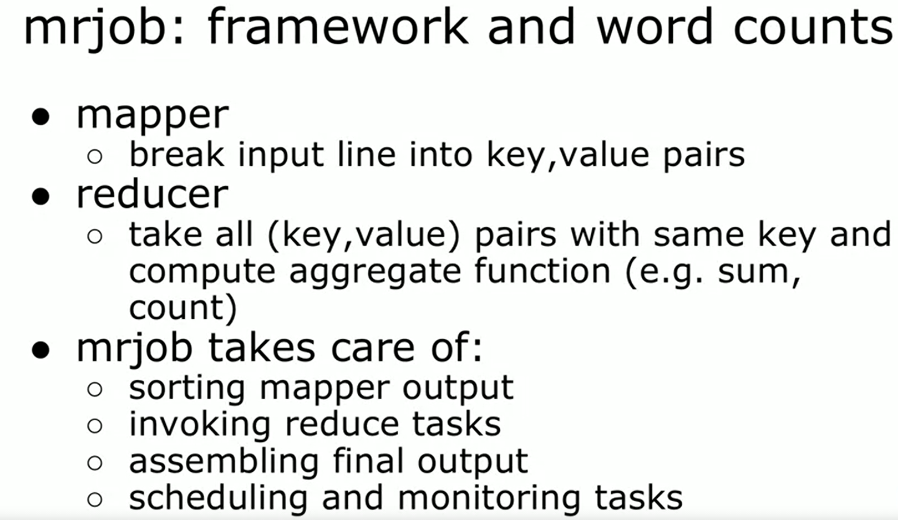

1. Use a mapper function to turn each item into zero or more key/value pairs. (Often this is called the map function, but there is already a Python function called map and we don’t need to confuse the two.)
2. Collect together all the pairs with identical keys.
3. Use a reducer function on each collection of grouped values to produce output values for the corresponding key.

Mrjob is going to be run as a script – with a !

%% file word\_count.py writes out the output of the cell into the file

This is how you run the script by invoking the python interpreter outside the notebook

!python most\_used\_word.py data/gutenberg/short.t1.txt

Recent systems in the Hadoop ecosystem provide abstractions that allow users to treat a cluster of computers more like a single computer—to automatically split up files and distribute storage over many machines, divide work into smaller tasks and execute them in a distributed manner, and recover from failures. The Hadoop ecosystem can automate a lot of the hassle of working with large data sets, and is far cheaper than HPC.

For example, when building a model that attempts to detect fraudulent purchases on a website, the data scientist must choose from a wide variety of potential features: fields that users are required to fill out, IP location info, login times, and click logs as users navigate the site. Each of these comes with its own challenges when converting to vectors fit for machine learning algorithms. A system needs to support more flexible transformations than turning a 2D array of doubles into a mathematical model.

Choosing the right features, picking the right algorithms, running the right significance tests, and finding the right hyperparameters all require experimentation.

Enter Apache Spark, an open source framework that combines an engine for distributing programs across clusters of machines with an elegant model for writing programs atop it. Spark, which originated at the UC Berkeley AMPLab and has since been contributed to the Apache Software Foundation, is arguably the first open source software that makes distributed programming truly accessible to data scientists.

Spark maintains MapReduce’s linear scalability and fault tolerance (and is resilient to the fact that failures that occur rarely on a single machine occur all the time on clusters of thousands of machines) but extends it in three important ways.

First, rather than relying on a rigid map-then-reduce format, its engine can execute a more general directed acyclic graph (DAG) of operators. This means that in situations where MapReduce must write out intermediate results to the distributed filesystem, Spark can pass them directly to the next step in the pipeline.

 Second, it complements this capability with a rich set of transformations that enable users to express computation more naturally. It has a strong developer focus and streamlined API that can represent complex pipelines in a few lines of code.

Third, Spark extends its predecessors with in-memory processing. Its Dataset and DataFrame abstractions enable developers to materialize any point in a processing pipeline into memory across the cluster, meaning that future steps that want to deal with the same data set need not recompute it or reload it from disk.

Supports fast moving read-evaluate-print loop (REPL) environments

Spark’s design principles are quite different from those of MapReduce. Unlike Hadoop MapReduce, Spark does not need to be run in tandem with Apache Hadoop—although it often is. Spark has inherited parts of its API, design, and supported formats from other existing computational frameworks, particularly DryadLINQ.[2](https://learning.oreilly.com/library/view/high-performance-spark/9781491943199/ch02.html#idm139899457072832) However, Spark’s internals, especially how it handles failures, differ from many traditional systems. Spark’s ability to leverage lazy evaluation within memory computations makes it particularly unique.

To get the most out of Spark, it is important to understand some of the principles used to design Spark and, at a cursory level, how Spark programs are executed. In this chapter, we will provide a broad overview of Spark’s model of parallel computing and a thorough explanation of the Spark scheduler and execution engine.

Apache Spark is an open source framework that provides methods to process data in parallel that are generalizable; the same high-level Spark functions can be used to perform disparate data processing tasks on data of different sizes and structures. On its own, Spark is not a data storage solution; it performs computations on Spark JVMs (Java Virtual Machines) that last only for the duration of a Spark application. Spark can be run locally on a single machine with a single JVM (called local mode). More often, Spark is used in tandem with a distributed storage system (e.g., HDFS, Cassandra, or S3) and a cluster manager—the storage system to house the data processed with Spark, and the cluster manager to orchestrate the distribution of Spark applications across the cluster. Spark currently supports three kinds of cluster managers: Standalone Cluster Manager, Apache Mesos, and **Hadoop YARN (**see [Figure 2-1](https://learning.oreilly.com/library/view/high-performance-spark/9781491943199/ch02.html#Spark_Architecture_Diagram)).



Spark allows users to write a program for the *driver* (or master node) on a cluster computing system that can perform operations on data in parallel. Spark represents large datasets as RDDs—immutable, distributed collections of objects—which are stored in the *executors* (or slave nodes). The objects that comprise RDDs are called partitions and may be (but do not need to be) computed on different nodes of a distributed system. The Spark cluster manager handles starting and distributing the Spark executors across a distributed system according to the configuration parameters set by the Spark application. The Spark execution engine itself distributes data across the executors for a computation. (See [Figure 2-4](https://learning.oreilly.com/library/view/high-performance-spark/9781491943199/ch02.html#SparkApp_Diagram).)

Rather than evaluating each transformation as soon as specified by the driver program, Spark evaluates RDDs lazily, computing RDD transformations only when the final RDD data needs to be computed (often by writing out to storage or collecting an aggregate to the driver). Spark can keep an RDD loaded in-memory on the executor nodes throughout the life of a Spark application for faster access in repeated computations. As they are implemented in Spark, RDDs are immutable, so transforming an RDD returns a new RDD rather than the existing one. As we will explore in this chapter, this paradigm of lazy evaluation, in-memory storage, and immutability allows Spark to be easy-to-use, fault-tolerant, scalable, and efficient.

**LAZY EVALUATION AND FAULT TOLERANCE**

Spark is fault-tolerant, meaning Spark will not fail, lose data, or return inaccurate results in the event of a host machine or network failure. Spark’s unique method of fault tolerance is achieved because each partition of the data contains the dependency information needed to recalculate the partition. Most distributed computing paradigms that allow users to work with mutable objects provide fault tolerance by logging updates or duplicating data across machines.

Spark core that interacts with Hadoop

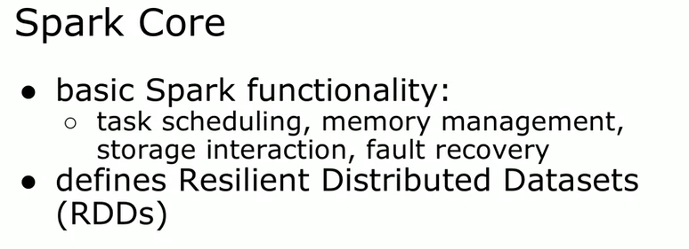

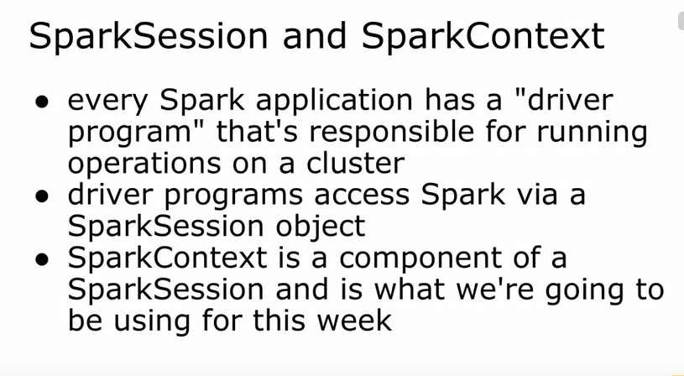

What I want you to take away from this is that the SparkSession manages

the distribution of computing and storage resources across a cluster of computers.

**Resilient Distributed Datasets**

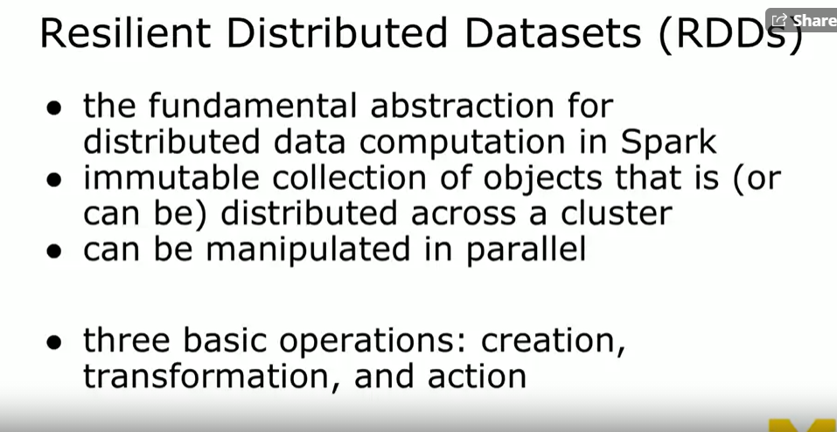



Best for unstructured data (such as text file) There are better ways for handling structured data like tables.

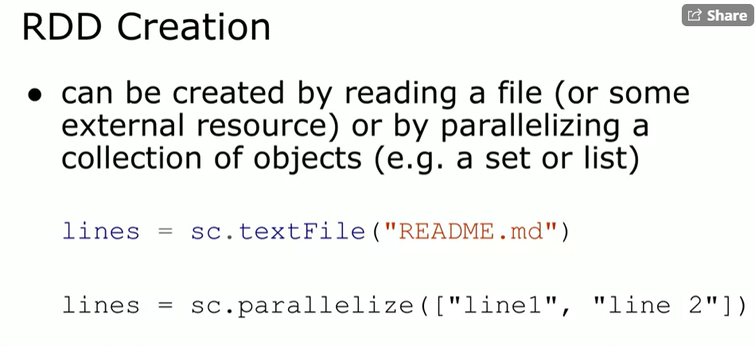



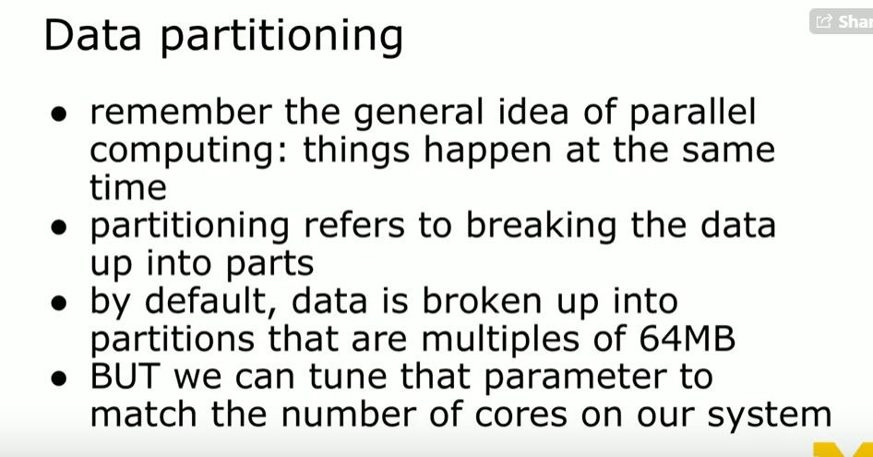

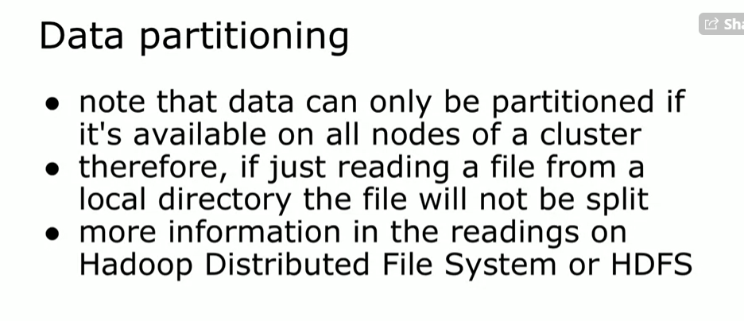

Note that the data can only be partitioned if it's available to

all nodes of a cluster.

So we need to figure out a way to get those out there,

if you're just reading a file from a local directory**, it will not be partitioned.**

**It will be parallelized so that each individual line is available, but it**

**will not be distributed across different partitions** that make use of the cluster.

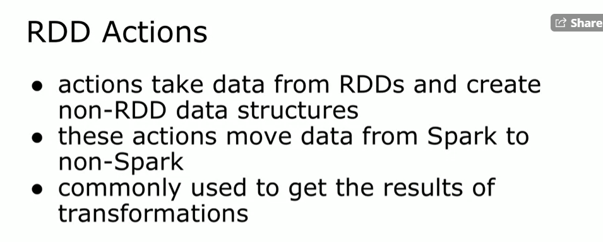

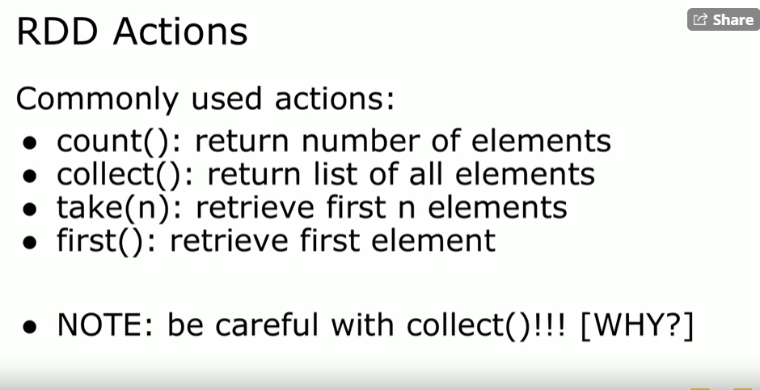

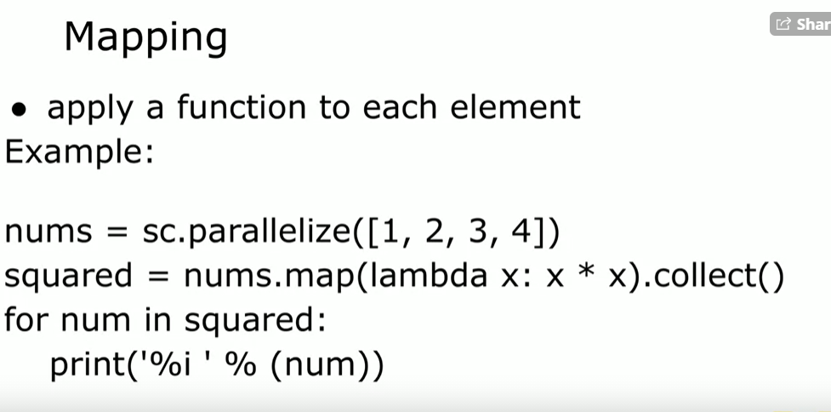

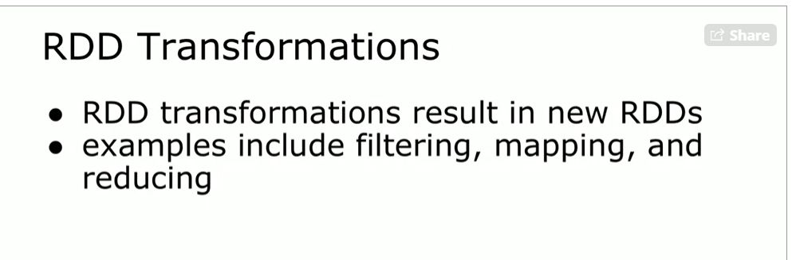

.

Now one thing to really think about when you're doing work in

Spark is you don't try to get complex, you don't filter for

error or warning, you actually do things in two steps.

And remember I mentioned that that **directed acyclic graph that dag,**

**the dag,** will figure out what the best combination of filters is for

you to achieve your desired outcome.

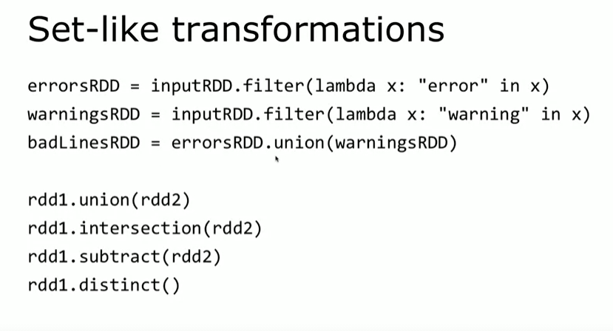

PairRDDs

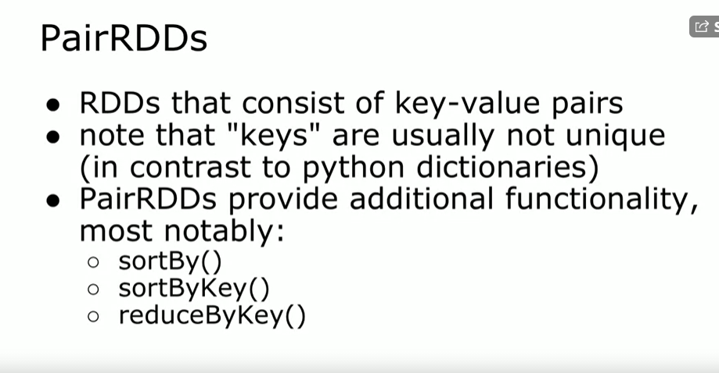

s.

And the important point here is that the keys will be sorted alphabetically.

If your keys happened to be numeric, you will have to figure out

a way to convert them into strings that sort appropriately.

Again, with the plain old sortBy, you can specify your lambda function,

sortByKey is a little bit different because you have to pad up

those numeric values to sort properly.

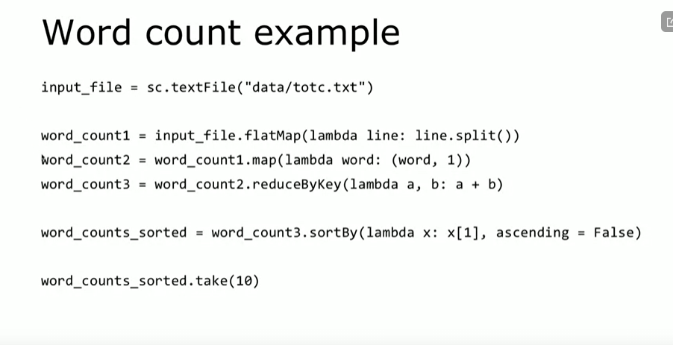

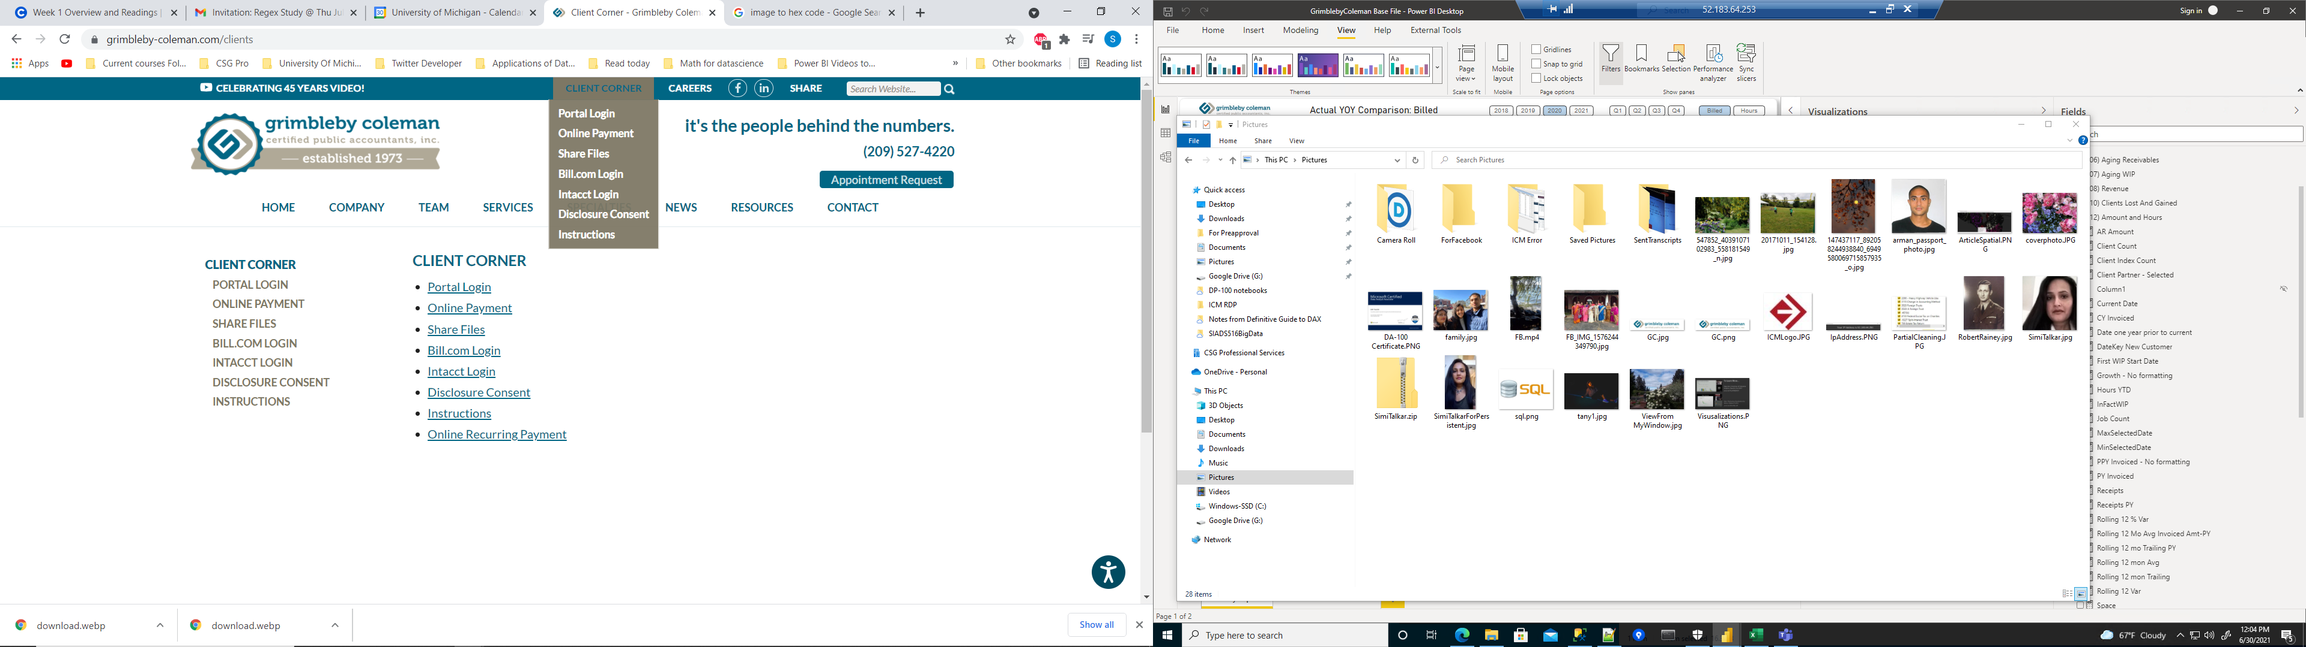

Recap of Resilient Distributed Datasets

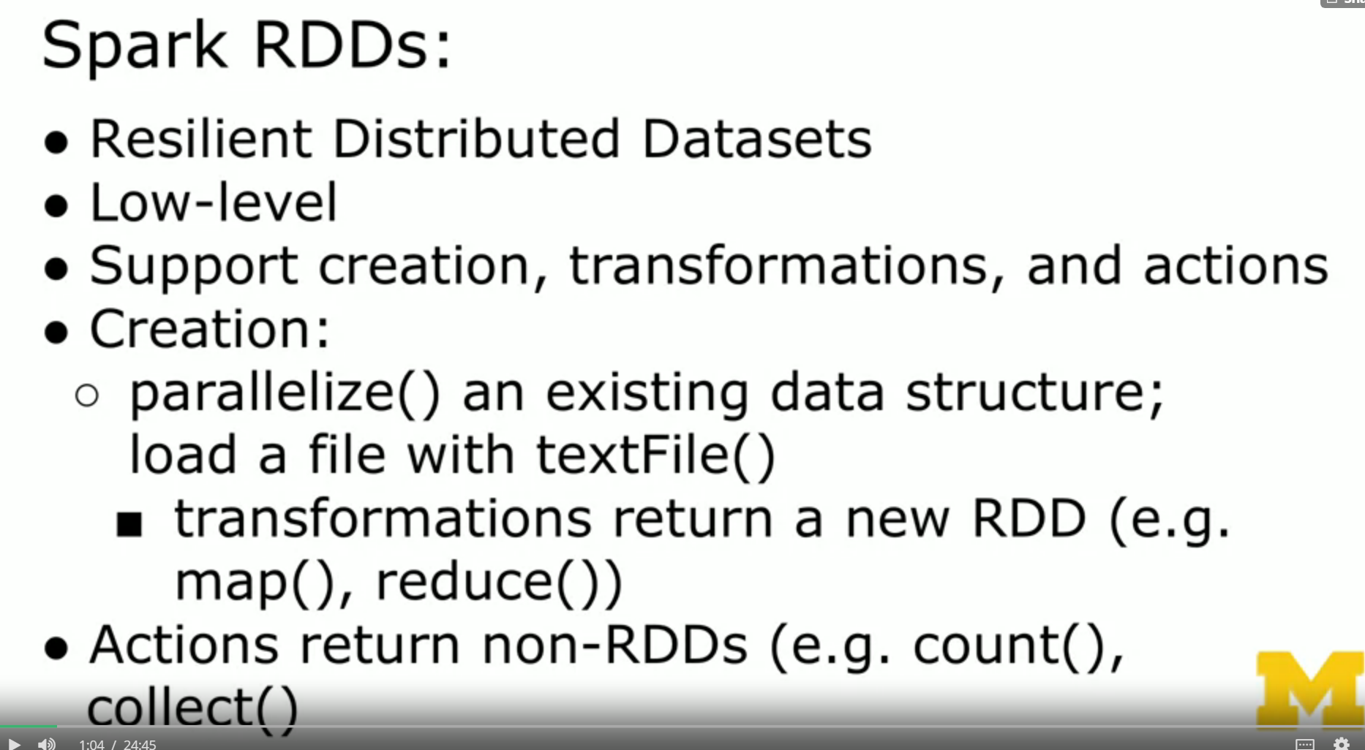

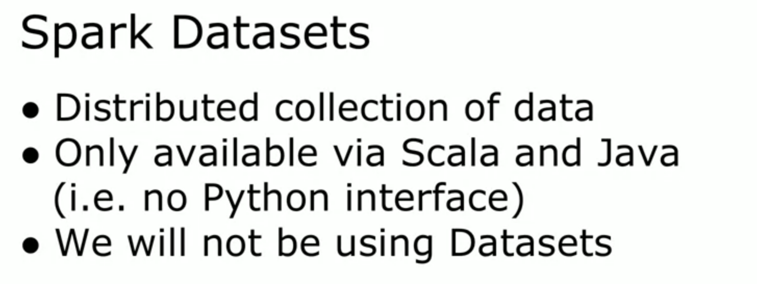

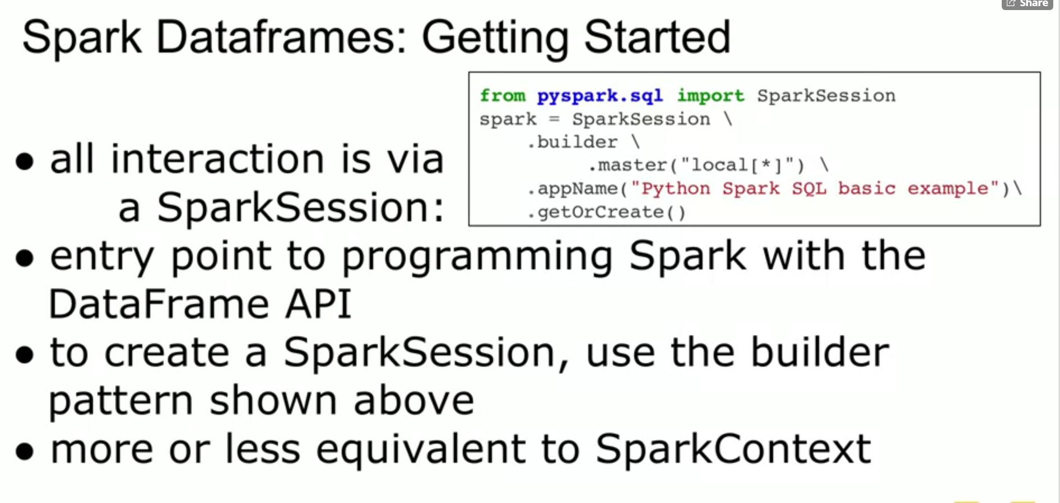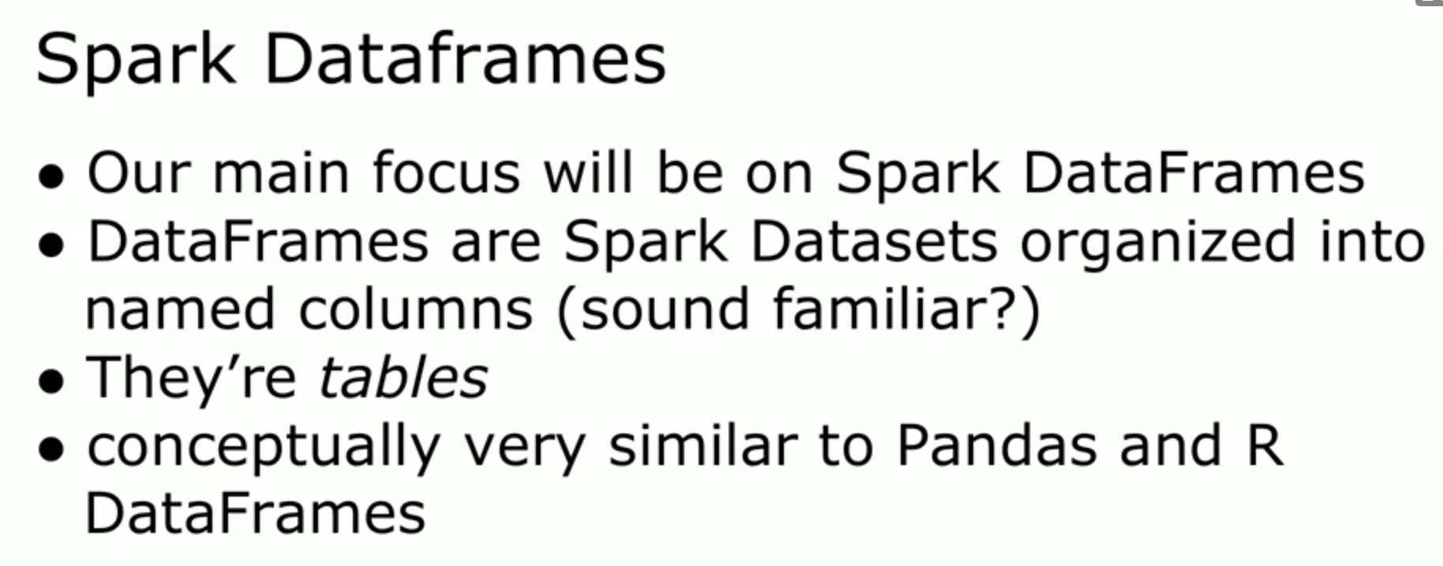

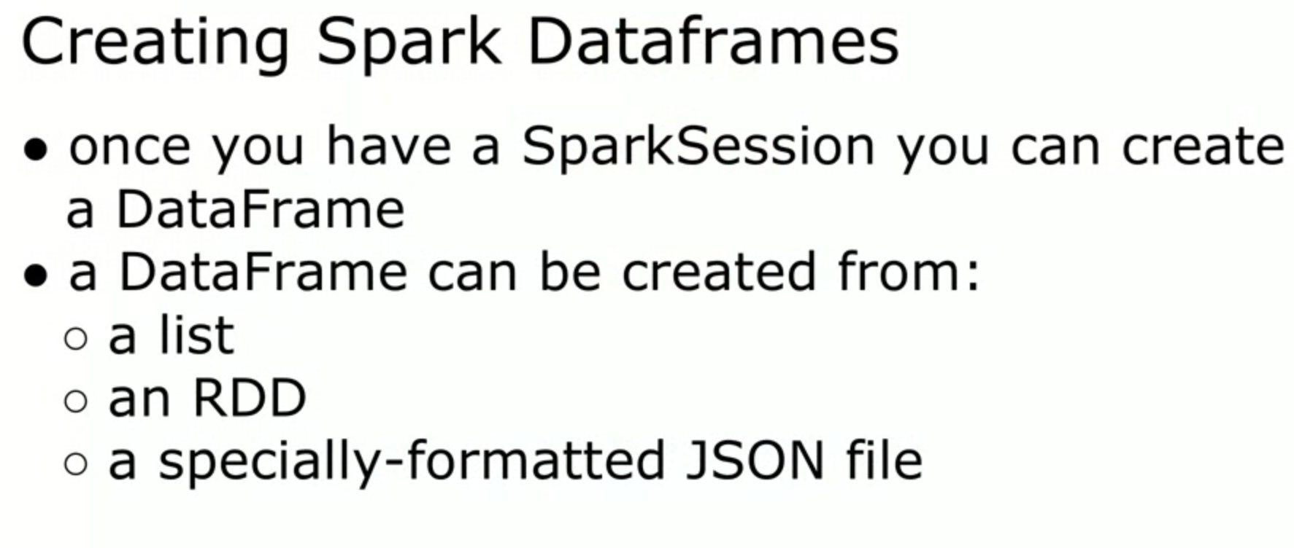

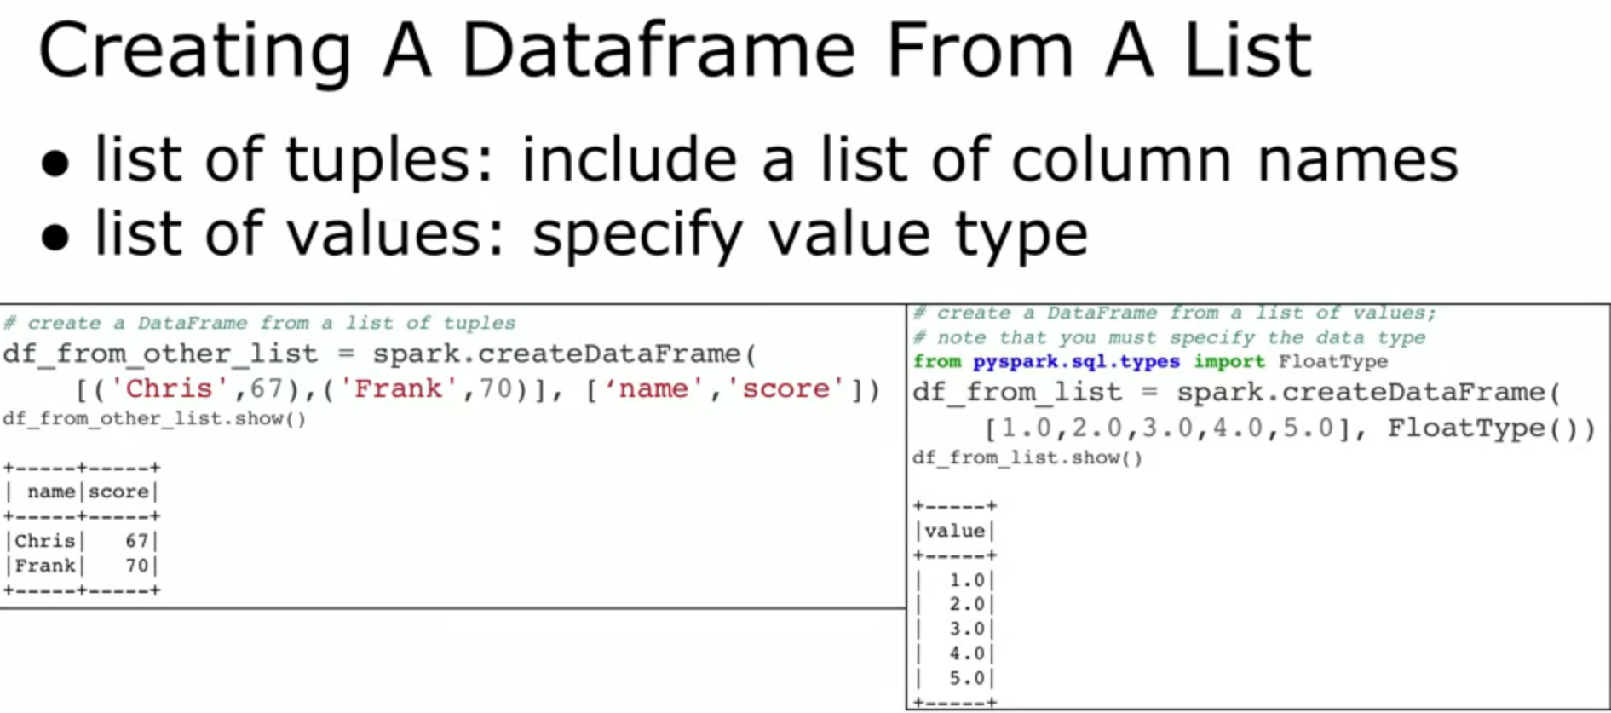

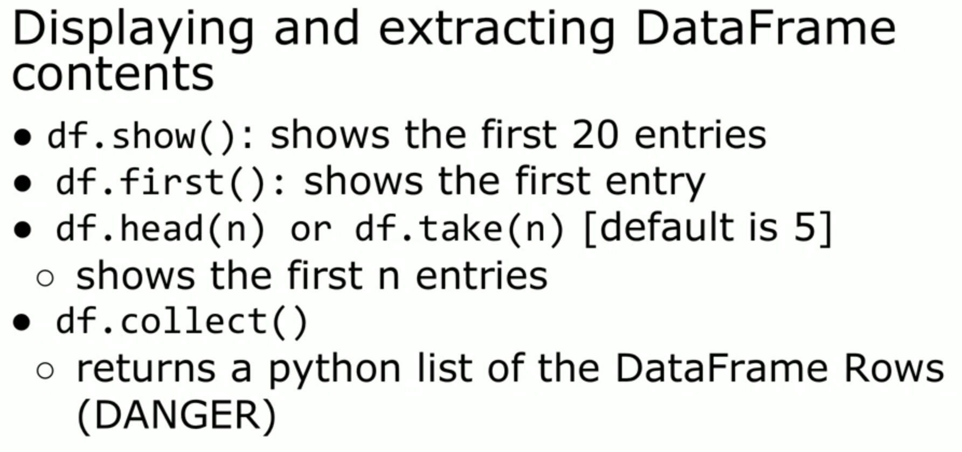

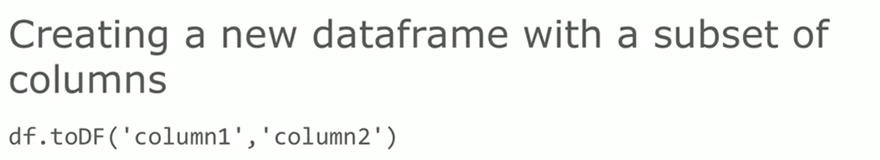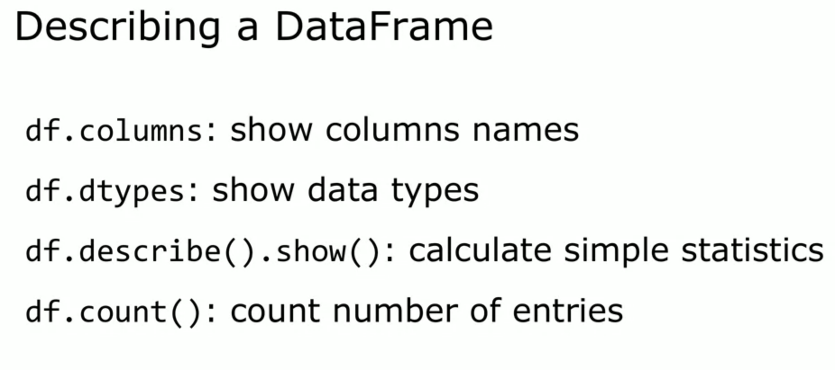

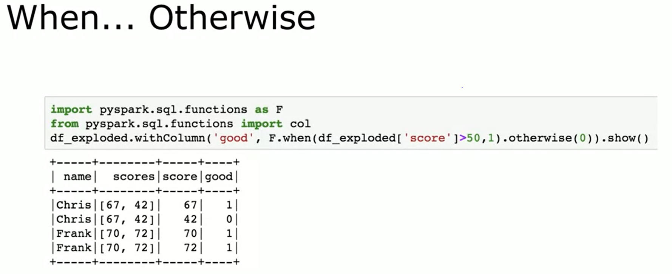

UDF in Spark SQL

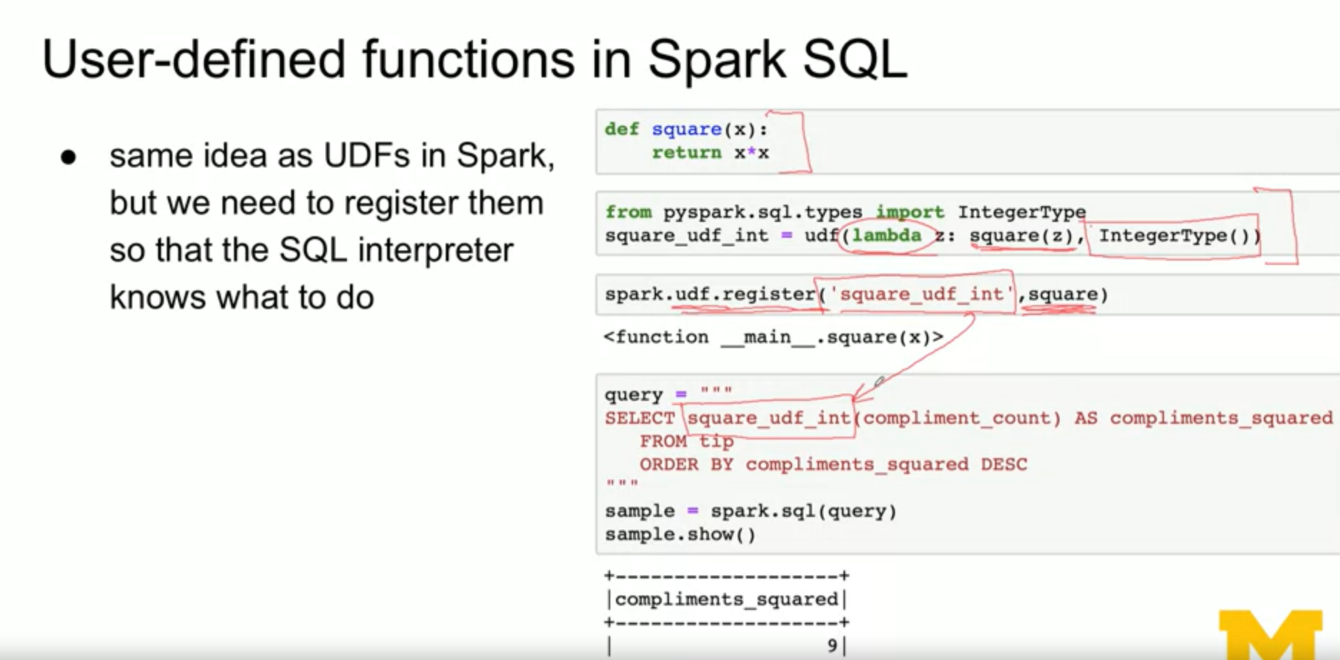

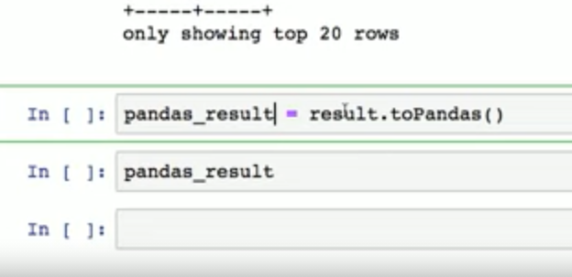

https://stackoverflow.com/questions/58507301/word-counter-with-pyspark

### For RDD style:

count\_rdd = df.select("tweets").rdd.flatMap(lambda x: x[0].split(' ')) \

.map(lambda x: (x, 1)).reduceByKey(lambda x,y: x+y)

S

### For Column style:

import pyspark.sql.functions as F

count\_df = df.withColumn('word', F.explode(F.split(F.col('tweets'), ' ')))\

.groupBy('word')\

.count()\

.sort('count', ascending=False)

You'll be able to use [regexp\_replace()](http://spark.apache.org/docs/2.1.0/api/python/pyspark.sql.html" \l "pyspark.sql.functions.regexp_replace) and [lower()](http://spark.apache.org/docs/2.1.0/api/python/pyspark.sql.html#pyspark.sql.functions.lower) from pyspark.sql.functions to do the preprocessing steps.

<https://stackoverflow.com/questions/58507301/word-counter-with-pyspark>

sqllines=dflines.createOrReplaceTempView('lines')

spark.sql("""select word, count(word) count from

(select explode(split(value,' ')) word from lines) words group by word order by count desc""").show(2)

From DP-100

Azure Databricks is a fully-managed version of the open-source [Apache Spark](https://spark.apache.org/) analytics and data processing engine.

The Databricks Runtime adds several key capabilities to Apache Spark workloads that can increase performance and reduce costs by as much as 10-100x when running on Azure, including:

* High-speed connectors to Azure storage services, such as Azure Blob Store and Azure Data Lake
* Auto-scaling and auto-termination of Spark clusters to minimize costs
* Caching
* Indexing
* Advanced query optimization

## Who is Databricks?

Databricks was founded by the creators of Apache Spark, Delta Lake, and MLflow.

## What does Databricks offer that is not Open-Source Spark?

* Databricks Workspace - Interactive Data Science & Collaboration
* Databricks Workflows - Production Jobs & Workflow Automation



* Databricks Runtime
* Databricks I/O (DBIO) - Optimized Data Access Layer



* Databricks Serverless - Fully Managed Auto-Tuning Platform
* Databricks Enterprise Security (DBES) - End-To-End Security & Compliance



Apache Spark



* At its core is the Spark Engine.
* The DataFrames API provides an abstraction above Resilient Distributed Datasets (RDDs) while simultaneously improving performance 5-20x over traditional RDDs with its Catalyst Optimizer.
* Spark ML provides high quality and finely tuned machine learning algorithms for processing big data.
* The Graph processing API gives us an easily approachable API for modeling pairwise relationships between people, objects, or nodes in a network.
* The Streaming APIs give us End-to-End Fault Tolerance, with Exactly-Once semantics, and the possibility for sub-millisecond latency.

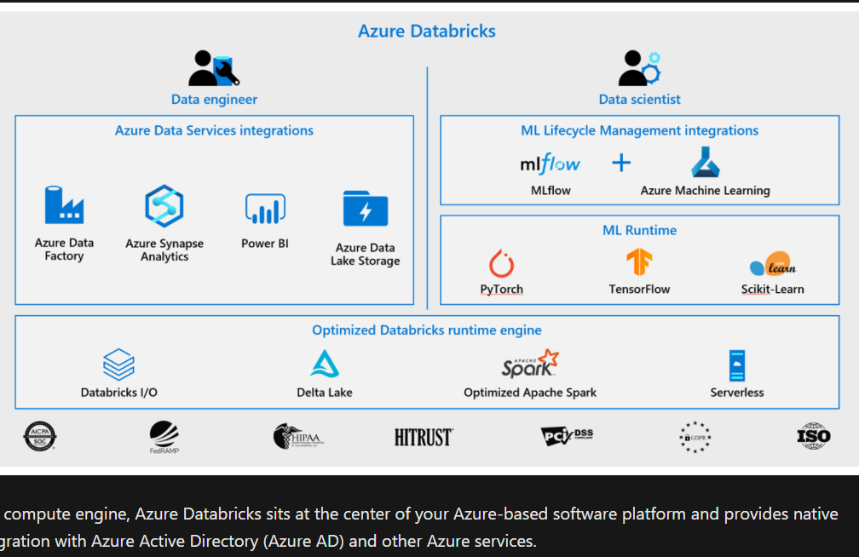

To use your notebook to run a code, you must attach it to a cluster. You can also detach your notebook from a cluster and attach it to another depending upon your organization's requirements.

* Detach your notebook from the cluster
* Restart the cluster
* Attach to another cluster
* Open the Spark UI
* View the log files of the driver

You can use Apache Spark notebooks to:

* Read and process huge files and data sets
* Query, explore, and visualize data sets
* Join disparate data sets found in data lakes
* Train and evaluate machine learning models
* Process live streams of data
* Perform analysis on large graph data sets and social networks

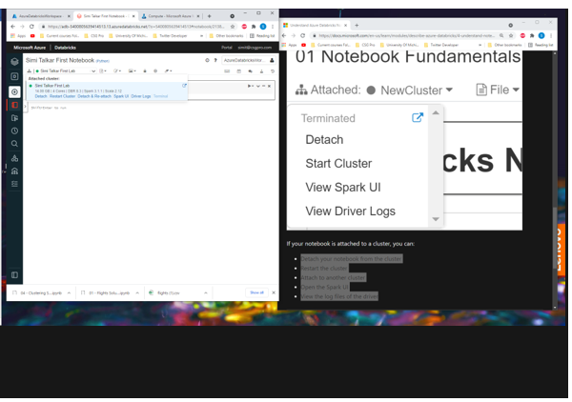

FIRST NOTEBOOK (DBC) <https://github.com/solliancenet/microsoft-learning-paths-databricks-notebooks/blob/master/data-engineering/DBC/01-Introduction-to-Azure-Databricks.dbc?raw=true>

After importing the notebook – ATTACH the cluster to it by selecting the cluster created earlier in the top left dropdown

%run "./Includes/Classroom-Setup"

dbutils.help()

* dbutils.fs.help()
* dbutils.meta.help()
* dbutils.notebook.help()
* dbutils.widgets.help()

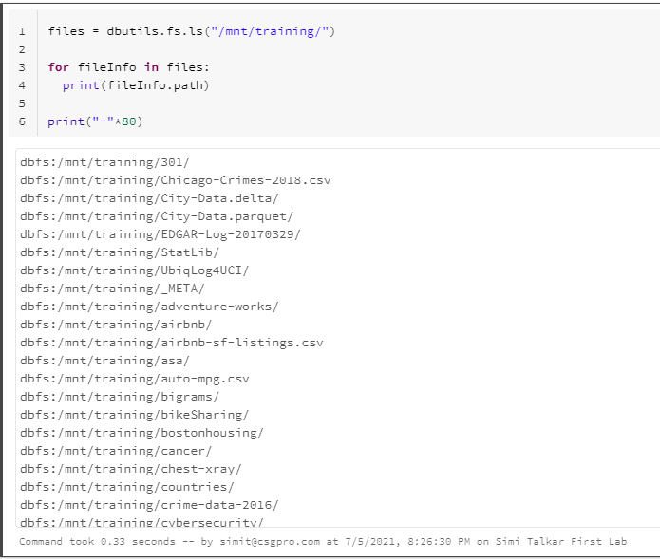

<https://medium.com/@lackshub/notes-for-databricks-crt020-exam-prep-9fbc97a2147e>

## **Application**

A user program built on Spark to perform a set of operations. Consists of a driver program and executors on the cluster. Each application has its own executor.

Descriptions of the elements of an application are in subsequent pages.

## **Driver**

The [JVM](https://en.wikipedia.org/wiki/Java_virtual_machine) process that controls the execution and maintains the state of a **Spark Application**. The roles of the driver are:

* creates the SparkContext
* respond to user’s program or input
* distributes and schedules work across executors
* maintain the state and tasks of the executors
* pipelines tranformations

RDDS are legacy-

<https://www.youtube.com/watch?v=4xsBQYdHgn8>

DAGs arise from the lazy implementation. In SQL thi is called Query plan

Moving from MapReduce – to distributed computing

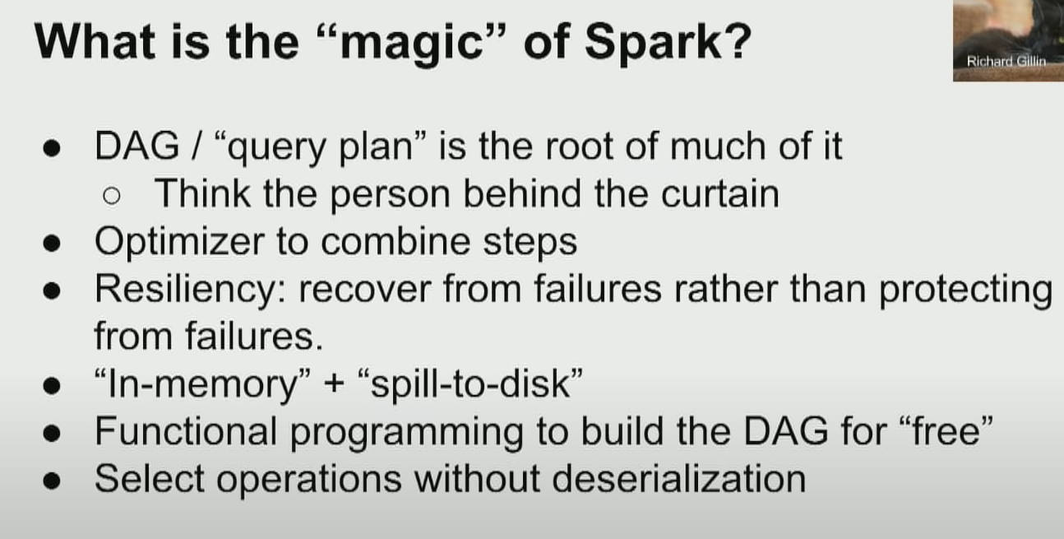

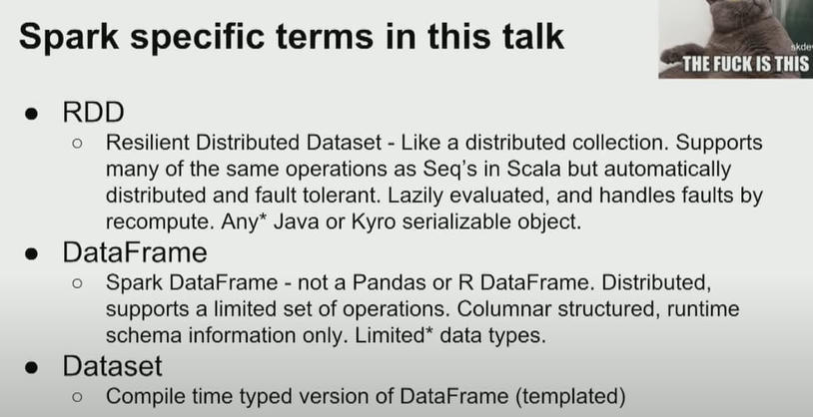

Immutable RDDs and Dataframes

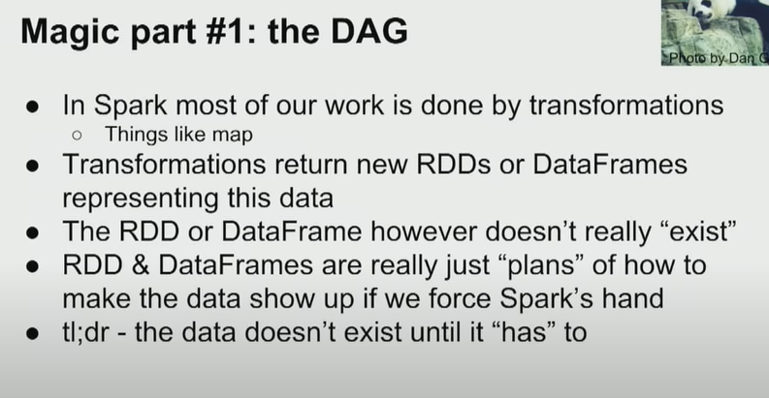

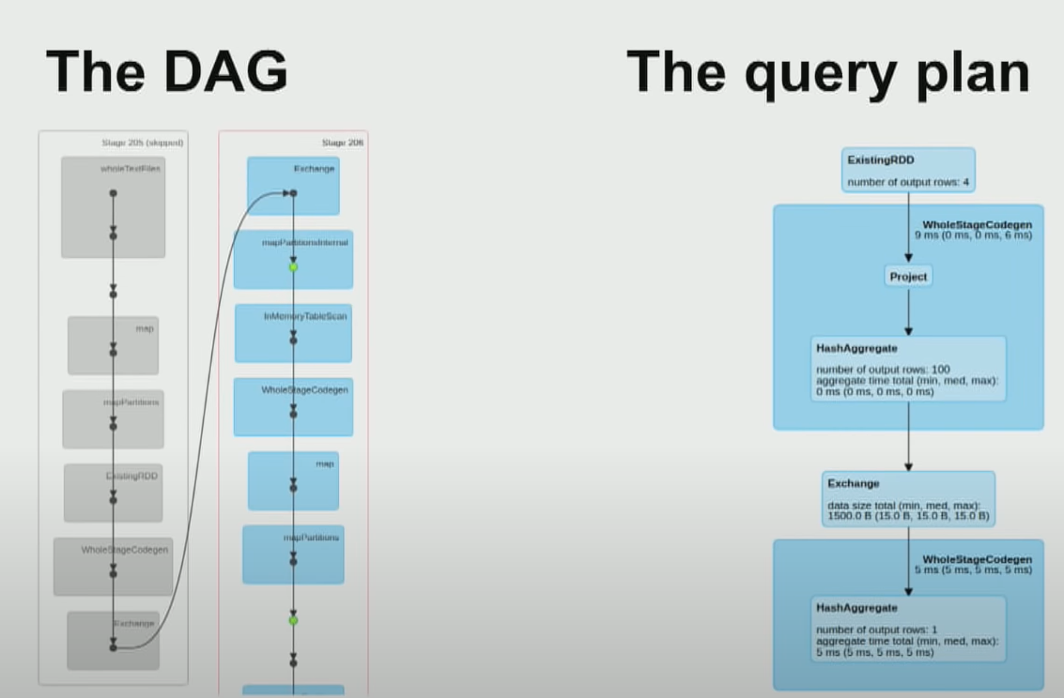

* 1. Lazy execution  
     2) Resiliency comes from recomputation in case of failure

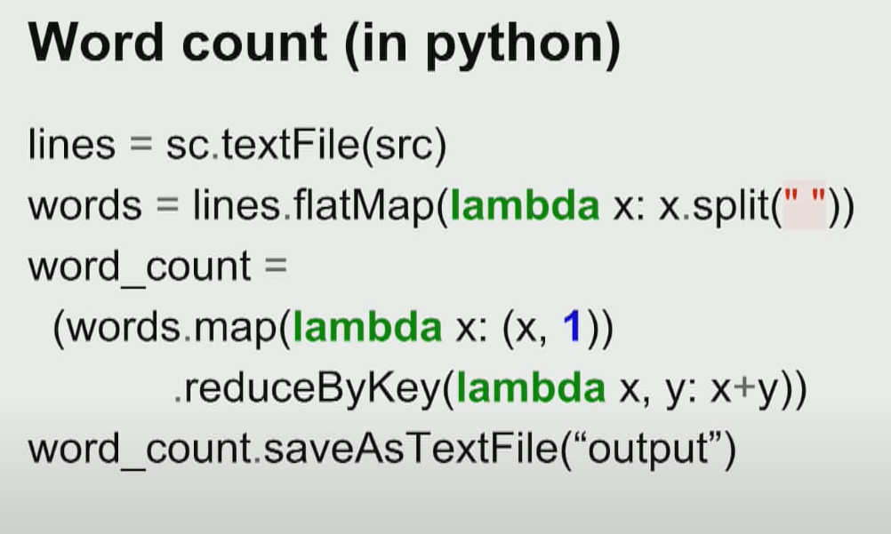

NOTE THE PairRDD above in the reduce by key where the count is being aggregated for every word – yes the number is being added to the word it appears but actually this is where all the counts for each words are aggregated.

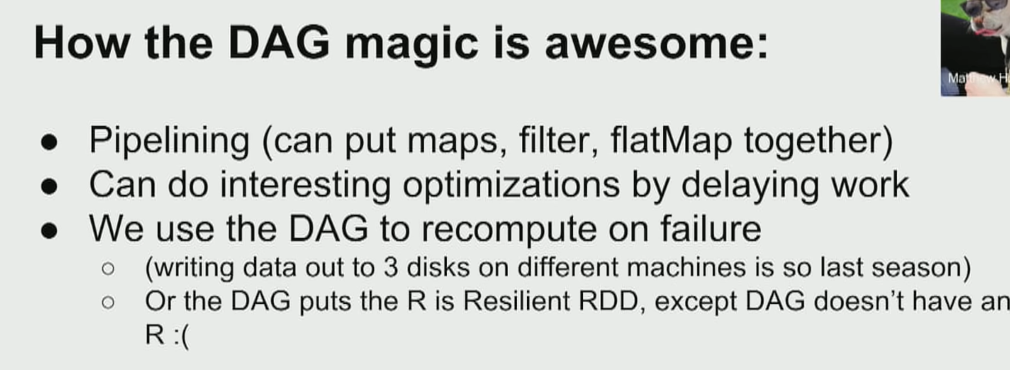

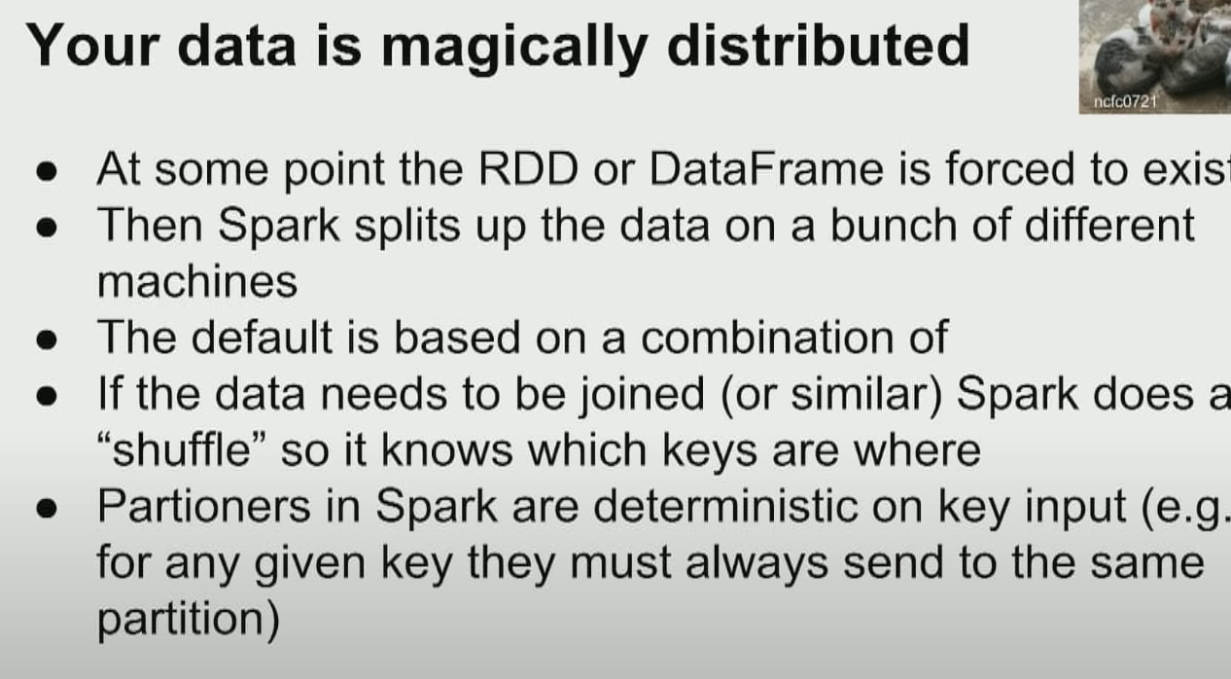

Shuffles when required by joins are expensive!

Worst case scenario when all the information is sent to one machine since there is only one key – or the (key) data is null.

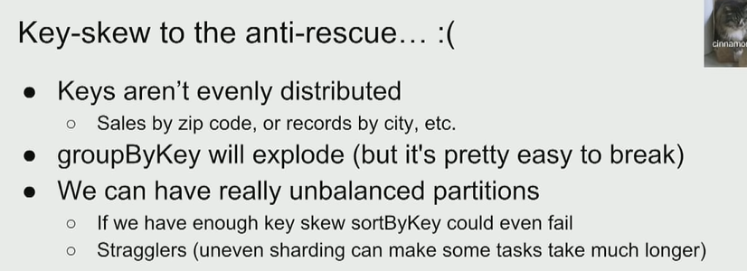

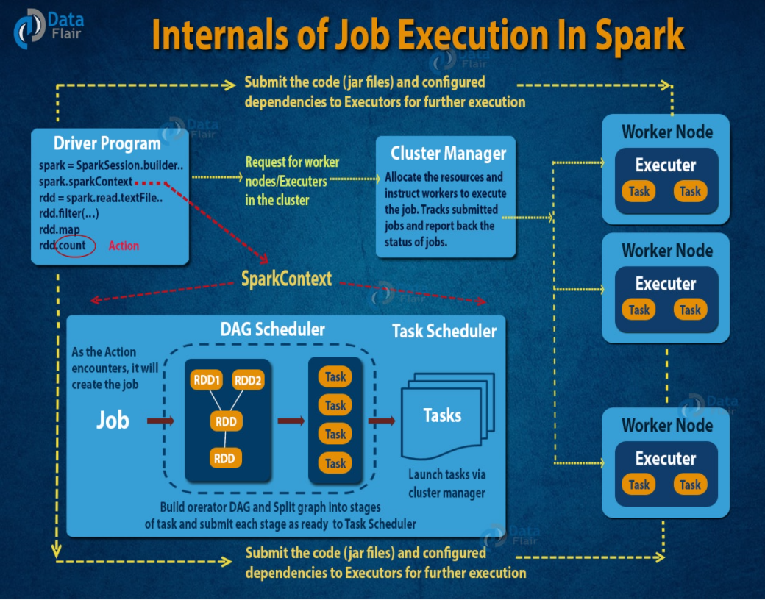

Why dataframes

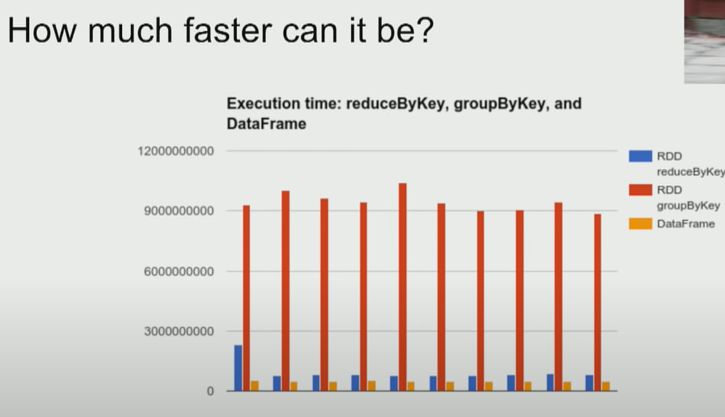

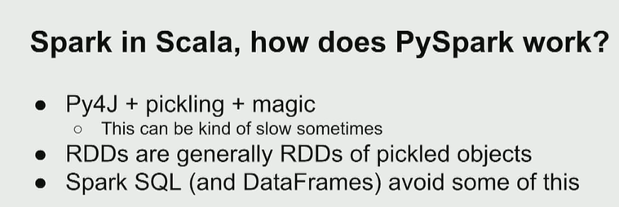

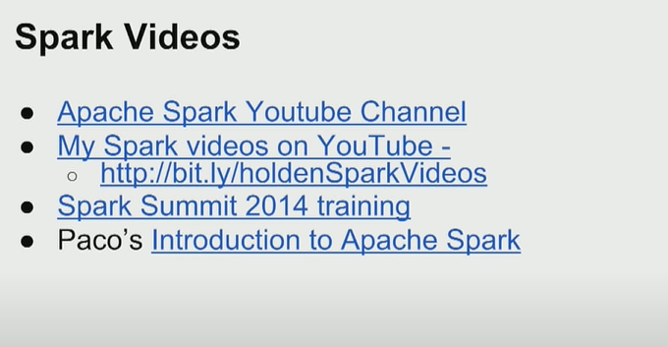

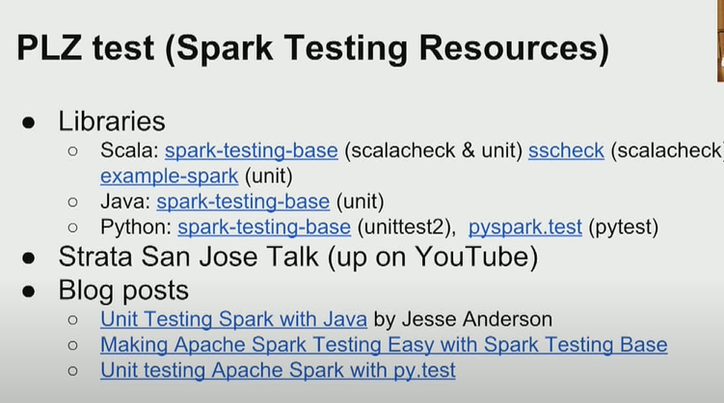

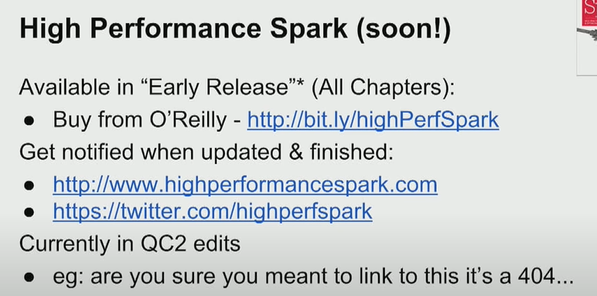

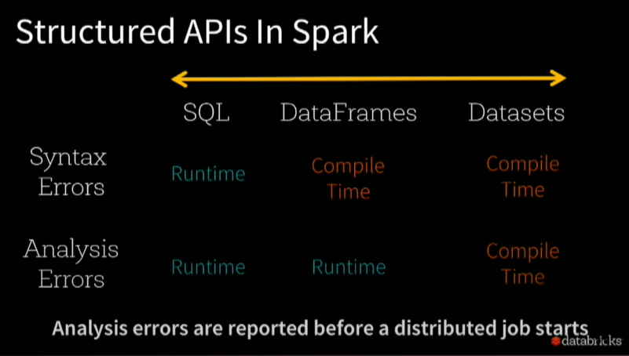

1. High volume - You must process an extremely large volume of data and need to scale out your compute accordingly
2. High velocity - You require streaming and real-time processing capabilities
3. Variety - Your data types are varied, from structured relational data sets and financial transactions to unstructured data such as chat and SMS messages, IoT devices, images, logs, MRIs, etc.

These characteristics are oftentimes called the "3 Vs of Big Data".

Structured API in spark

<https://www.youtube.com/watch?v=Ofk7G3GD9jk>

Azure Databricks and Spark

From a high level, the Azure Databricks service launches and manages Apache Spark clusters within your Azure subscription. Apache Spark clusters are groups of computers that are treated as a single computer and handle the execution of commands issued from notebooks. Using a master-worker type architecture, clusters allow processing of data to be parallelized across many computers to improve scale and performance. They consist of a Spark Driver (master) and worker nodes. The driver node sends work to the worker nodes and instructs them to pull data from a specified data source.

In Databricks, the notebook interface is the driver program. This driver program contains the main loop for the program and creates distributed datasets on the cluster, then applies operations (transformations & actions) to those datasets. Driver programs access Apache Spark through a SparkSession object regardless of deployment location.



At the time of cluster creation, you specify the types and sizes of the virtual machines (VMs) to use for both the Driver and Worker nodes, but Azure Databricks manages all other aspects of the cluster.

Internally, Azure Kubernetes Service (AKS) is used to run the Azure Databricks control-plane and data-planes via containers running on the latest generation of Azure hardware (Dv3 VMs), with NvMe SSDs capable of blazing 100us latency on IO. These make Databricks I/O performance even better.

 As you may know, Spark is a Distributed computing environment. The unit of distribution is a Spark Cluster. Every Cluster has a Driver and one or more executors. Work submitted to the Cluster is split into as many independent Jobs as needed. This is how work is distributed across the Cluster's nodes. Jobs are further subdivided into tasks.

The input to a job is partitioned into one or more partitions. These partitions are the unit of work for each slot. In between tasks, partitions may need to be re-organized and shared over the network.

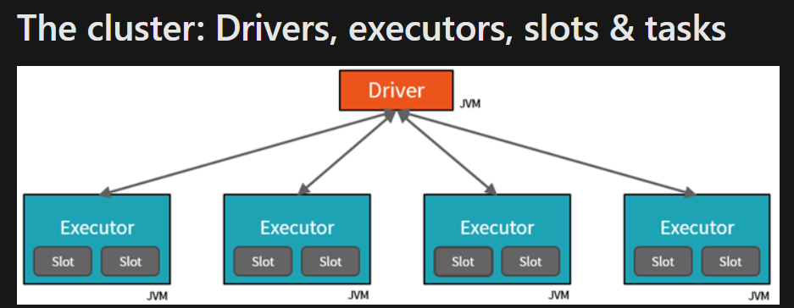

* The **Driver** is the JVM in which our application runs.
* The secret to Spark's awesome performance is parallelism.
  + Scaling vertically is limited to a finite amount of RAM, Threads and CPU speeds.
  + Scaling horizontally means we can simply add new "nodes" to the cluster almost endlessly.
* We parallelize at two levels:
  + The first level of parallelization is the **Executor** - a Java virtual machine running on a node, typically, one instance per node.
  + The second level of parallelization is the **Slot** - the number of which is determined by the number of cores and CPUs of each node.
* Each **Executor** has a number of **Slots** to which parallelized **Tasks** can be assigned to it by the **Driver**.
* From a developer's and learner's perspective my primary focus is on...
  + The number of **Partitions** my data is divided into.
  + The number of **Slots** I have for parallel execution.
  + How many **Jobs** am I triggering?
  + And lastly the **Stages** those jobs are divided into.
* **The supported Databricks notebook format is the DBC file type.**

Apache Spark offers high performance when you need to work with Big Data workloads, because of its distributed computing architecture. When working with high volume, high velocity, or a variety of data.

Second Notebook: <https://github.com/solliancenet/microsoft-learning-paths-databricks-notebooks/blob/master/data-engineering/DBC/03-Reading-and-writing-data-in-Azure-Databricks.dbc?raw=true>



This is guaranteed to trigger one job.

A *Job* is triggered anytime we are "physically" **required to touch the data**.

In some cases, **one action may create multiple jobs** (multiple reasons to touch the data).

In this case, the reader has to **"peek" at the first line** of the file to determine how many columns of data we have.

# A reference to our tab-separated-file

csvFile = "/mnt/training/wikipedia/pageviews/pageviews\_by\_second.tsv"

tempDF = (spark.read # The DataFrameReader

.option("sep", "\t") # Use tab delimiter (default is comma-separator)

.csv(csvFile) # Creates a DataFrame from CSV after reading in the file

)

tempDF.printSchema()

display(tempDF)

(spark.read # The DataFrameReader

.option("sep", "\t") # Use tab delimiter (default is comma-separator)

.option("header", "true") # Use first line of all files as header

.csv(csvFile) # Creates a DataFrame from CSV after reading in the file

.printSchema()

)

(spark.read # The DataFrameReader

.option("header", "true") # Use first line of all files as header

.option("sep", "\t") # Use tab delimiter (default is comma-separator)

.option("inferSchema", "true") # Automatically infer data types

.csv(csvFile) # Creates a DataFrame from CSV after reading in the file

.printSchema()

)

**Reading CSV w/InferSchema**

* we still have three columns
* all three columns are still **nullable**
* all three columns have their proper names
* **two jobs were executed** (not one as in the previous example)
* our three columns now have distinct data types:
  + **timestamp** == **timestamp**
  + **site** == **string**
  + **requests** == **integer**

**DEFINE A SCHEMA TO PREVENT TWO JOBS CREATED BY INFERRING SCHEMA**

The difference here is that we are going to define the schema beforehand and hopefully avoid the execution of any extra jobs.

# Required for StructField, StringType, IntegerType, etc.

from pyspark.sql.types import \*

csvSchema = StructType([

StructField("timestamp", StringType(), False),

StructField("site", StringType(), False),

StructField("requests", IntegerType(), False)

])

public StructField(String name,

[DataType](https://spark.apache.org/docs/latest/api/java/org/apache/spark/sql/types/DataType.html) dataType,

boolean nullable,

[Metadata](https://spark.apache.org/docs/latest/api/java/org/apache/spark/sql/types/Metadata.html) metadata)

(spark.read # The DataFrameReader

.option('header', 'true') # Ignore line #1 - it's a header

.option('sep', "\t") # Use tab delimiter (default is comma-separator)

.schema(csvSchema) # Use the specified schema

.csv(csvFile) # Creates a DataFrame from CSV after reading in the file

# .printSchema()

)

* All three columns are **NOT** nullable because we declared them as such.
* All three columns have their proper names
* Zero jobs were executed
* Our three columns now have distinct data types:
  + **timestamp** == **string**
  + **site** == **string**
  + **requests** == **integer**

**Question:** Why were there no jobs?

%fs head /mnt/training/wikipedia/pageviews/pageviews\_by\_second.tsv

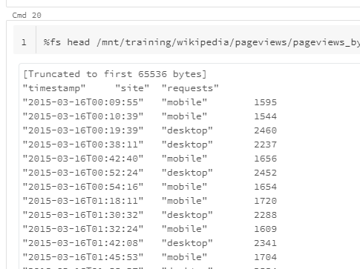

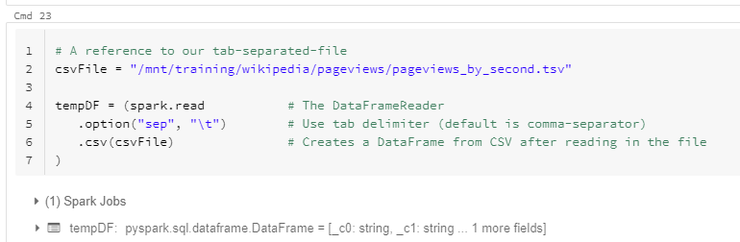

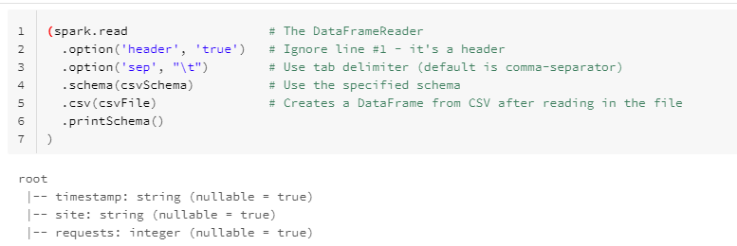

csvDF = (spark.read

.option('header', 'true')

.option('sep', "\t")

.schema(csvSchema)

.csv(csvFile)

)

print("Partitions: " + str(csvDF.rdd.getNumPartitions()) )

printRecordsPerPartition(csvDF)

print("-"\*80)

**JSON Lines**

Much like the CSV reader, the JSON reader also assumes...

* That there is one JSON object per line and...
* That it's delineated by a new-line.

This format is referred to as **JSON Lines** or **newline-delimited JSON**

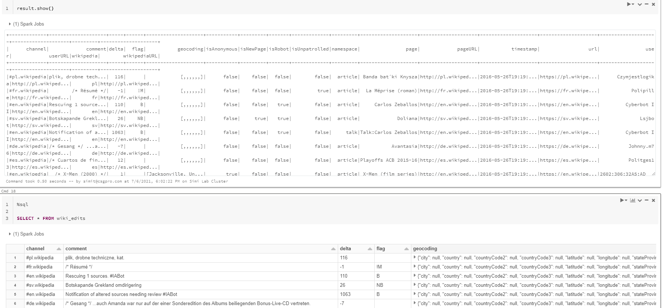

In Databricks notebook .DBC you can open out nested columns. You can also access these nested columns using identifier

%sql

SELECT channel, page, geocoding.city, geocoding.latitude, geocoding.longitude

FROM wiki\_edits

WHERE geocoding.city IS NOT NULL

**Review: Reading from JSON w/ InferSchema**

While there are similarities between reading in CSV & JSON there are some key differences:

* We only need one job even when inferring the schema.
* There is no header which is why there isn't a second job in this case - the column names are extracted from the JSON object's attributes.
* Unlike CSV which reads in 100% of the data, the JSON reader only samples the data.  
  **Note:** In Spark 2.2 the behavior was changed to read in the entire JSON file.

# Required for StructField, StringType, IntegerType, etc.

from pyspark.sql.types import \*

jsonSchema = StructType([

StructField("channel", StringType(), True),

StructField("comment", StringType(), True),

StructField("delta", IntegerType(), True),

StructField("flag", StringType(), True),

StructField("geocoding", StructType([

StructField("city", StringType(), True),

StructField("country", StringType(), True),

StructField("countryCode2", StringType(), True),

StructField("countryCode3", StringType(), True),

StructField("stateProvince", StringType(), True),

StructField("latitude", DoubleType(), True),

StructField("longitude", DoubleType(), True)

]), True),

StructField("isAnonymous", BooleanType(), True),

StructField("isNewPage", BooleanType(), True),

StructField("isRobot", BooleanType(), True),

StructField("isUnpatrolled", BooleanType(), True),

StructField("namespace", StringType(), True),

StructField("page", StringType(), True),

StructField("pageURL", StringType(), True),

StructField("timestamp", StringType(), True),

StructField("url", StringType(), True),

StructField("user", StringType(), True),

StructField("userURL", StringType(), True),

StructField("wikipediaURL", StringType(), True),

StructField("wikipedia", StringType(), True)

])

**: Reading from JSON w/ User-Defined Schema**

* Just like CSV, providing the schema avoids the extra jobs.
* The schema allows us to rename columns and specify alternate data types.
* Can get arbitrarily complex in its structure.

### About Parquet => METADATA Files



* Free & Open Source.
* Increased query performance over row-based data stores.
* Provides efficient data compression.
* Designed for performance on large data sets.
* Supports limited schema evolution.
* Is a splittable "file format".
* A [Column-Oriented](https://en.wikipedia.org/wiki/Column-oriented_DBMS) data store

**Row Format**                   **Column Format**

|  |  |  |  |  |  |  |  |
| --- | --- | --- | --- | --- | --- | --- | --- |
| **ID** | **Name** | **Score** |  | **ID:** | 1 | 2 | 3 |
| 1 | john | 4.1 |  | **Name:** | john | mike | sally |
| 2 | mike | 3.5 |  | **Score:** | 4.1 | 3.5 | 6.4 |
| 3 | sally | 6.4 |  |  |  |  |  |

See also

**Review: Reading from Parquet Files**

* We do not need to specify the schema - the column names and data types are stored in the parquet files.
* Only one job is required to **read** that schema from the parquet file's metadata.
* Unlike the CSV or JSON readers that have to load the entire file and then infer the schema, the parquet reader can "read" the schema very quickly because it's reading that schema from the metadata.

In most/many cases, people do not provide the schema for Parquet files because reading in the schema is such a cheap process.

## Registering Tables in Databricks

So far we've seen purely programmatic methods for reading in data.

Databricks allows us to "register" the equivalent of "tables" so that they can be easily accessed by all users.

There are several benefits to this strategy:

* Once setup, it never has to be done again
* It is available for any user on the platform (permissions permitting)
* Minimizes exposure of credentials
* No real overhead to reading the schema (no infer-schema)
* Easier to advertise available datasets to other users

Loading a file using URL

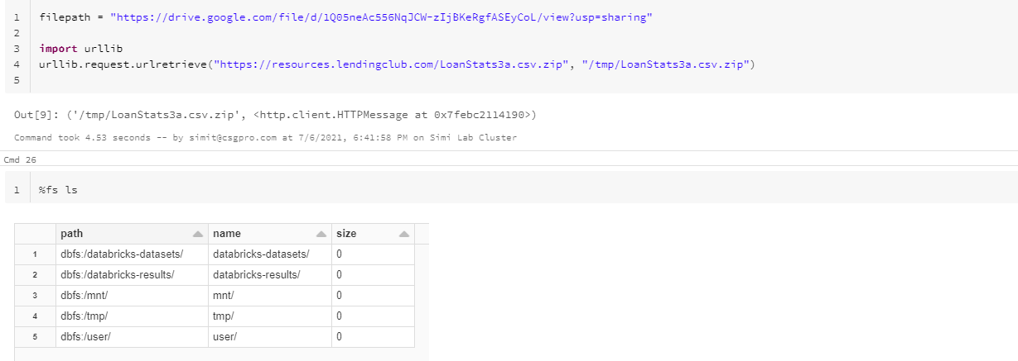

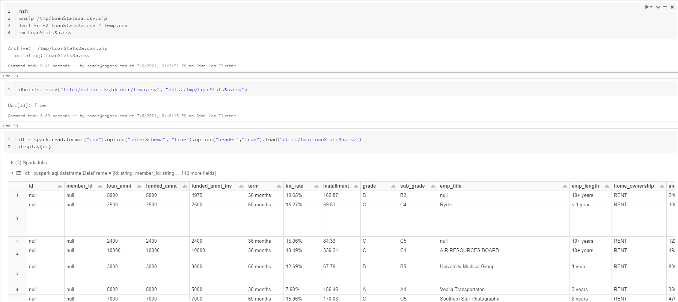

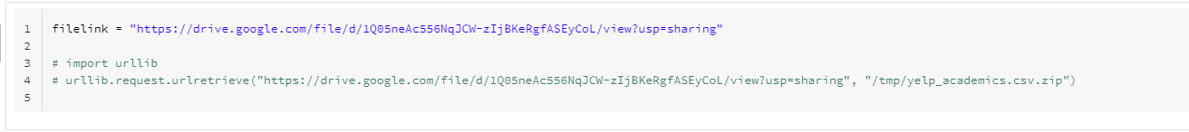

Getting data from Github

import urllib

urllib.request.urlretrieve("https://resources.lendingclub.com/LoanStats3a.csv.zip", "/tmp/LoanStats3a.csv.zip")

%sh

unzip /tmp/LoanStats3a.csv.zip

tail -n +2 LoanStats3a.csv > temp.csv

rm LoanStats3a.csv

dbutils.fs.mv("file:/databricks/driver/temp.csv", "dbfs:/tmp/LoanStats3a.csv")

df = spark.read.format("csv").option("inferSchema", "true").option("header","true").load("dbfs:/tmp/LoanStats3a.csv")

display(df)

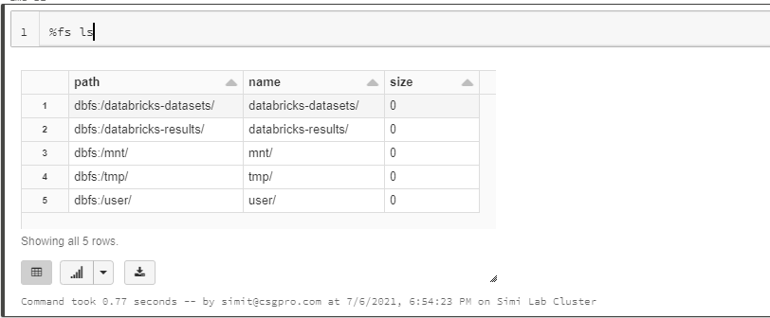

READING a FILE FROM GITHUB

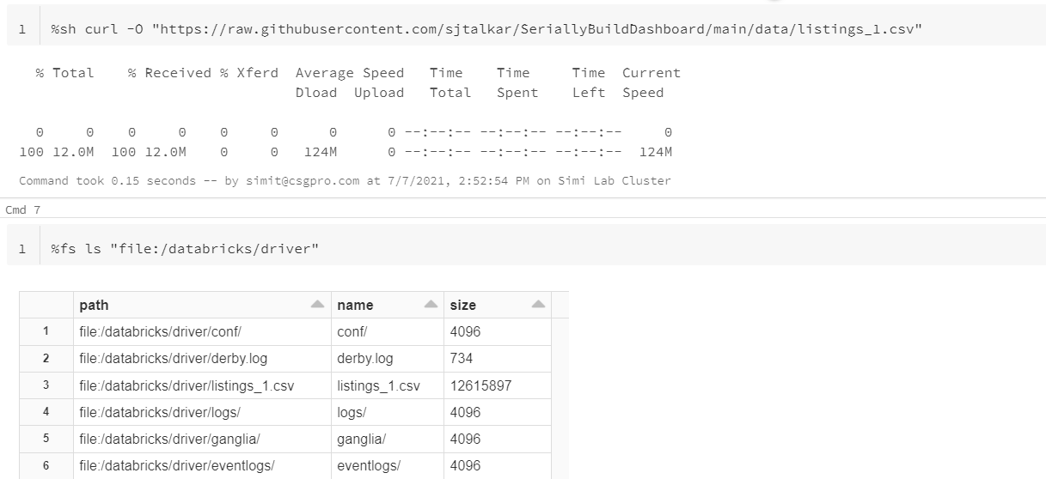

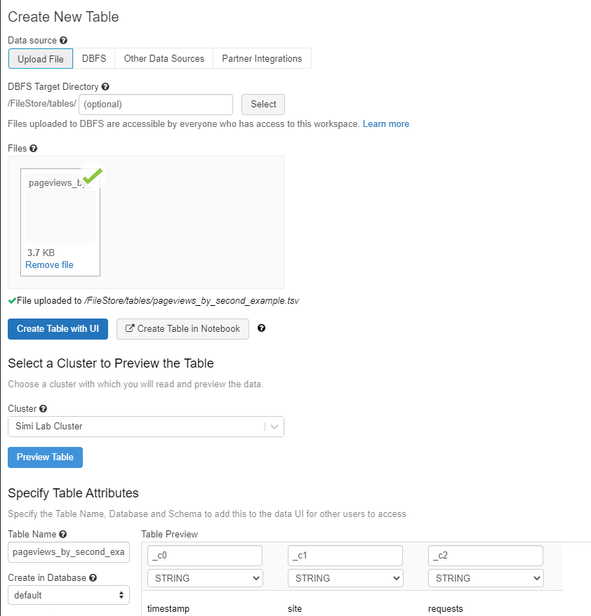

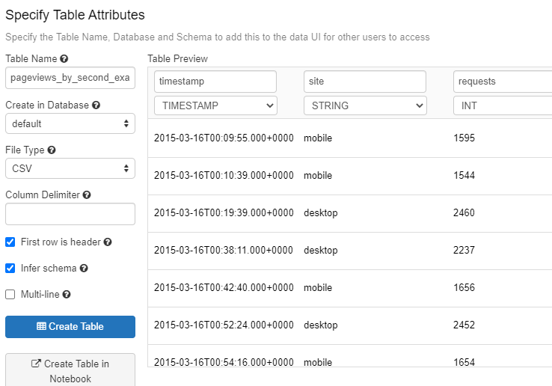

**Review: Reading from Tables**

* No job is executed - the schema is stored in the table definition on Databricks.
* The data types shown here are those we defined when we registered the table.
* In our case, the file was uploaded to Databricks and is stored on the DBFS.
  + If we used JDBC, it would open the connection to the database and read it in.
  + If we used an object store (like what is backing the DBFS), it would read the data from source.
* The "registration" of the table simply makes future access, or access by multiple users easier.
* The users of the notebook cannot see username and passwords, secret keys, tokens, etc.

%sql

select \* from pageviews\_by\_second\_example\_tsv limit(5)

UDFs provide even more functionality, but it is best to use a built in function wherever possible.

**UDF Drawbacks:**

* UDFs cannot be optimized by the Catalyst Optimizer
* The function **has to be serialized** and sent out to the executors
* In the case of Python, there is even more overhead - we have to **spin up a Python interpreter** on every Executor to run the UDF (e.g. Python UDFs much slower than Scala UDFs)

***Note #1:****The method createOrReplaceTempView(..) is bound to the SparkSession meaning it will be discarded once the session ends.*

***Note #2:***On the other hand, the method createOrReplaceGlobalTempView(..) is bound to the spark application.\*

*Or to put that another way, I can use createOrReplaceTempView(..) in this notebook only. However, I can call* ***createOrReplaceGlobalTempView****(..) in this notebook and then access it from another.*

Writing DATA

from pyspark.sql.types import \*

csvSchema = StructType([

StructField("timestamp", StringType(), False),

StructField("site", StringType(), False),

StructField("requests", IntegerType(), False)

])

csvFile = "/mnt/training/wikipedia/pageviews/pageviews\_by\_second.tsv"

csvDF = (spark.read

.option('header', 'true')

.option('sep', "\t")

.schema(csvSchema)

.csv(csvFile)

)

fileName = userhome + "/pageviews\_by\_second.parquet"

print("Output location: " + fileName)

(csvDF.write # Our DataFrameWriter

.option("compression", "snappy") # One of none, snappy, gzip, and lzo

.mode("overwrite") # Replace existing files

.parquet(fileName) # Write DataFrame to Parquet files

)

EXERCISE:

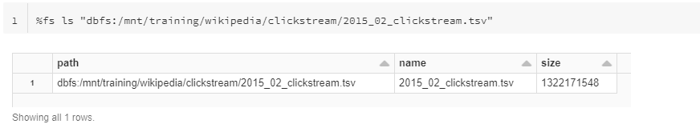

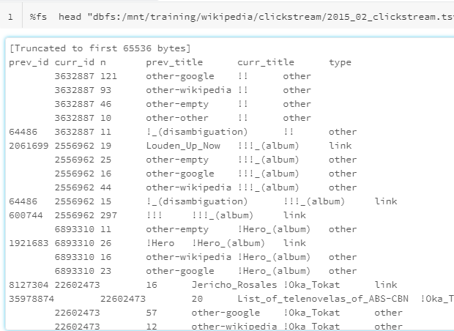

from pyspark.sql.types import StructType, StructField

from pyspark.sql.types import IntegerType, StringType

fileName = "dbfs:/mnt/training/wikipedia/clickstream/2015\_02\_clickstream.tsv"

testDF.printSchema()

columns = testDF.dtypes

assert len(columns) == 6, "Expected 6 columns but found " + str(len(columns))

assert columns[0][0] == "prev\_id", "Expected column 0 to be \"prev\_id\" but found \"" + columns[0][0] + "\"."

assert columns[0][1] == "int", "Expected column 0 to be of type \"int\" but found \"" + columns[0][1] + "\"."

assert columns[1][0] == "curr\_id", "Expected column 1 to be \"curr\_id\" but found \"" + columns[1][0] + "\"."

assert columns[1][1] == "int", "Expected column 1 to be of type \"int\" but found \"" + columns[1][1] + "\"."

assert columns[2][0] == "n", "Expected column 2 to be \"n\" but found \"" + columns[2][0] + "\"."

assert columns[2][1] == "int", "Expected column 2 to be of type \"int\" but found \"" + columns[2][1] + "\"."

assert columns[3][0] == "prev\_title", "Expected column 3 to be \"prev\_title\" but found \"" + columns[3][0] + "\"."

assert columns[3][1] == "string", "Expected column 3 to be of type \"string\" but found \"" + columns[3][1] + "\"."

assert columns[4][0] == "curr\_title", "Expected column 4 to be \"curr\_title\" but found \"" + columns[4][0] + "\"."

assert columns[4][1] == "string", "Expected column 4 to be of type \"string\" but found \"" + columns[4][1] + "\"."

assert columns[5][0] == "type", "Expected column 5 to be \"type\" but found \"" + columns[5][0] + "\"."

assert columns[5][1] == "string", "Expected column 5 to be of type \"string\" but found \"" + columns[5][1] + "\"."

print("Congratulations, all tests passed... that is if no jobs were triggered :-)\n")

csvSchema = StructType([

StructField("prev\_id", IntegerType(), True),

StructField("curr\_id", IntegerType(), True),

StructField("n", IntegerType(), True),

StructField("prev\_title", StringType(), False),

StructField("curr\_title", StringType(), False),

StructField("type", StringType(), True),

])

testDF = (spark.read

.option('header', 'true')

.option('sep', "\t")

.schema(csvSchema)

.csv(fileName)

)

* Use the count() method to count rows in a DataFrame
* Use the display() function to display a DataFrame in the Notebook
* Cache a DataFrame for quicker operations if the data is needed a second time
* Use the limit function to display a small set of rows from a larger DataFrame
* Use select() to select a subset of columns from a DataFrame
* Use distinct() and dropDuplicates to remove duplicate data
* Use drop() to remove columns from a DataFrame

<https://github.com/solliancenet/microsoft-learning-paths-databricks-notebooks/blob/master/data-engineering/DBC/04-Working-With-Dataframes.dbc?raw=true>

Working with Dataframes

path = source + "/wikipedia/pagecounts/staging\_parquet\_en\_only\_clean/"

files = dbutils.fs.ls(path)

display(files)

Databricks Utilities (dbutils) make it easy to perform powerful combinations of tasks. You can use the utilities to work with object storage efficiently, to chain and parameterize notebooks, and to work with secrets. dbutils are not supported outside of notebooks.

* We'll start with the object **spark**, an instance of SparkSession and the entry point to Spark 2.0 applications.
* From there we can access the read object which gives us an instance of DataFrameReader.

pagecountsEnAllDF = (spark # Our SparkSession & Entry Point  
.read # Our DataFrameReader  
.parquet(parquetDir) # Returns an instance of DataFrame)

print(pagecountsEnAllDF) # Python hack to see the data type

total = pagecountsEnAllDF.count()

* 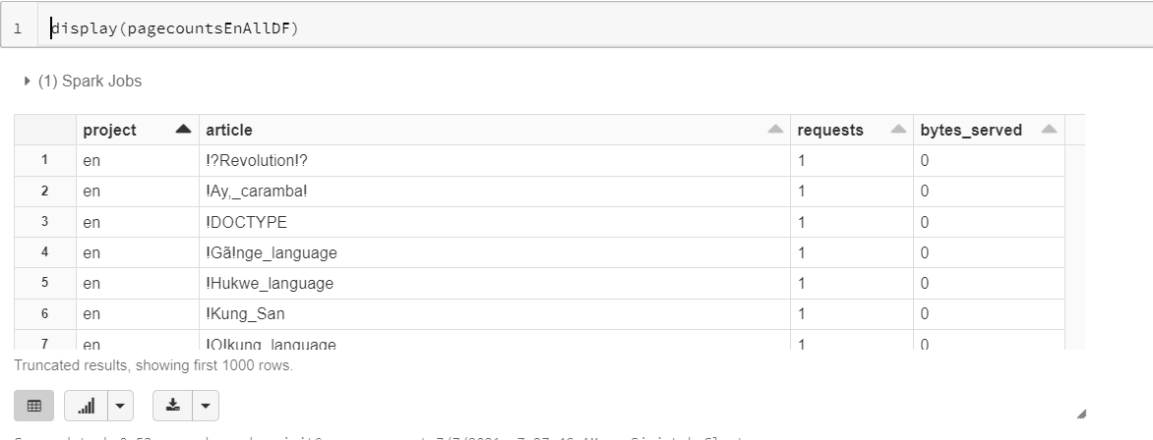\show(..) is part of core spark - display(..) is specific to our notebooks.

display(..) is more powerful - with it, you can...

* Download the results as CSV
* Render line charts, bar chart & other graphs, maps and more.
* See up to 1000 records at a time.

distinctDF = (pagecountsEnAllDF # Our original DataFrame from spark.read.parquet(..)

.select("project") # Drop all columns except the "project" column

.distinct() # Reduce the set of all records to just the distinct column.

)

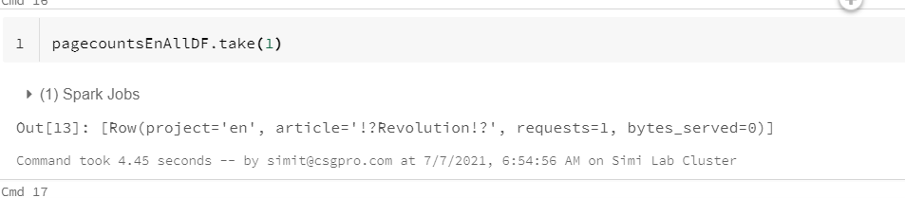

Connecting to Google drive data from Databricks

<https://www.cdata.com/kb/tech/googledrive-jdbc-azure-databricks.rst>

spark.udf.register("my\_function", f)

Correct. spark.udf.register("my\_function", f) is the correct syntax to register the UDF in SQL namespace.



spark.register\_udf("my\_function", f)



spark.udf.register(f, "my\_function")

2.

What is the correct syntax for specifying the return type for an UDF?



my\_udf = udf(f, "LongType()")



my\_udf = udf(f, "long")

Correct, my\_udf = udf(f, "long") is one of the ways to specify the return type.



my\_udf = udf(f, return\_type = "long")

3.

What is one of the drawbacks of UDFs?



UDFs cannot operate on DataFrames.



The function has to be serialized and sent out to the executors.

Correct, thus it is best to use a built-in function wherever possible.



UDFs can only operate one row at a time.

1.

Which DataFrame method do you use to create a temporary view?



createTempView()



createTempViewDF()



createOrReplaceTempView()

2.

How do you create a DataFrame object?



Introduce a variable name and equate it to something like myDataFrameDF =



Use the createDataFrame() function



Use the DF.create() syntax

3.

How do you cache data into the memory of the local executor for instant access?



.save().inMemory()



.inMemory().save()



.cache()

4.

What is the Python syntax for defining a DataFrame in Spark from an existing Parquet file in DBFS?



IPGeocodeDF = parquet.read("dbfs:/mnt/training/ip-geocode.parquet")



IPGeocodeDF = spark.read.parquet("dbfs:/mnt/training/ip-geocode.parquet")



IPGeocodeDF = spark.parquet.read("dbfs:/mnt/training/ip-geocode.parquet")

User Defined Functions

<https://github.com/MicrosoftDocs/mslearn_databricks/blob/main/udf/1.1.0/Labs.dbc>

DELTA LAKE

Delta Lake is provided as a managed offering as part of your Azure Databricks account, and helps you combine the best capabilities of Data Lake, data warehousing, and a streaming ingestion system.

* Learn about the key features and use cases of Delta Lake.
* Use Delta Lake to create, append, and upsert tables.
* Perform optimizations in Delta Lake.
* Compare different versions of a Delta table using Time Machine.